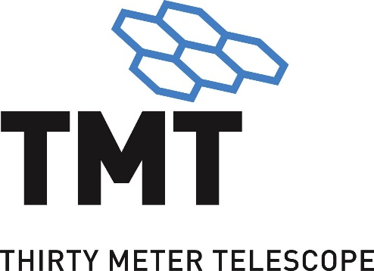

TMT Science Cases Flowdown and Traceability

TMT.PSC.TEC.22.002.REL03

October 3, 2022

DOCUMENT APPROVAL

Author Release Note:
See Document Change Record

Prepared By:

\Signature on file\ |  | \Signature on file\
Warren Skidmore  TMT System Scientist |  | John Miles  TMT Instrumentation Senior Systems Engineer

\Signature on file\ |  | \Signature on file\
Kayla Hardie  TMT Systems Engineer |  | Bart Fordham  TMT Systems Engineer

Approval:

\Signature on file\

Gelys Trancho
TMT Systems Engineering Group Leader

Document Change Record

Revision | Modifications | Release Approval | Date Released
REL03 | Major update to include motivating and challenging science cases and traceability between SRD and DSC | Docushare Routing #91318 | October 3, 2022
REL02 | Assigned a new DCC number |  | August 10, 2022
REL01 | Initial Release |  | July 7, 2010
DRF01 | Initial draft – L. Simard |  | 16 January 2009

TABLE OF CONTENTS
1. Introduction 6
1.1 Applicable Documents 6
1.2 Reference Documents 7
2. Motivating Science Cases 8
3. Science Flowdown Process 10
3.1 Identifying Observing Capabilities, AO Facilities, and Instruments to Support the Motivating Science Cases 10
3.2 Science Case Decomposition into Observing Programs 15
3.3 Observing Program Flowdown into Level 0 Requirements 15
3.4 Level 0 Requirement Flowdown to System and Subsystem Requirements 16
3.5 Traceability Visualization 17
4. Key Performance Relative to Driving Science Cases 19
4.1 Key Performance Parameter Flowdown Analysis 19
4.2 Key Performance Parameter Tracking 22
5. Driving Science Cases 23
6. Appendix A: Science Capabilities Matrix Parameters Definitions 28
7. Appendix B: Key Performance Parameters (KPP) Diagrams 33
8. Appendix C: Abbreviations 45

Table of Figures

Figure 2-1: Timeline of the inputs and revisions of the TMT Detailed Science Case. 9
Figure 3-1: TMT Science Flowdown Process. 10
Figure 3-2: An excerpt of the Science Capabilities Matrix in DOORS showing a subset of the fields that describe each observing program 15
Figure 3-3: An excerpt of the Science Capabilities Matrix flowdown to Level 0 Requirements in DOORS 16
Figure 3-4: An excerpt of the same requirement as in Figure 3-3 in the SRD, flowing to a level 1 OAD requirement and illustrating the traceability to higher and lower levels 16
Figure 3-5: An excerpt showing the same requirement as in Figure 3-4 in the OAD flowing to level 2 requirements and illustrating the traceability to higher and lower levels 17
Figure 3-6: A visual illustration from TraceTree showing the flow of a TMT Science Case/Observing program (UC-0-DSC-0232) to all of its flowdown requirements. Thick red outline shows the KPP performance requirements described in Section 4. 18
Figure 4-1: A visual representation showing some of the science cases for a single high-level requirement (for this example there are 26 related science cases of which 12 are shown). Thick black outlines indicate the driving science cases (3 are seen and there are a total of 6 for this particular requirement). Thick red outlines highlight the KPP drivers. 20
Figure 4-2: The astrometry KPP flow from TraceTree. Thick red outlines highlight the KPP drivers. 20
Figure 4-3: A TraceTree diagram for interconnected KPPs 21
Figure 4-4: A snapshot of the time series of the technical performance measurement for the vibration KPP 22
Figure 7-1: Wavefront Error, NFIRAOS NGSAO 33
Figure 7-2: Wavefront Error, NFIRAOS LGS MCAO 34
Figure 7-3: Image Quality, Seeing-Limited (PSSN) 35
Figure 7-4: Image Quality, Seeing-Limited Off-Axis (PSSNF) 36
Figure 7-5: Throughput (TPUT) 37
Figure 7-6: Astrometry (ASTR) 38
Figure 7-7: Photometry, Absolute (PHOTA) 38
Figure 7-8: Photometry, Differential (PHOTD) 38
Figure 7-9: Pupil Stability (PUPIL) 39
Figure 7-10: Pointing Error (POINT) 40
Figure 7-11: Vibration (VIB) 41
Figure 7-12: Preset Time 42
Figure 7-13: Acquisition Time, AO (ACQAO) 43
Figure 7-14: Acquisition Time, Seeing-Limited (ACQSL) 43
Figure 7-15: Heat Dissipation (HEAT) 44

LIST of TABLES

Table 3-1: The key design parameters of the observatory and how they are implemented in each observing mode. 12
Table 5-1: Driving science cases 24
Table 6-1: Science Capabilities Matrix Parameter Definitions 28

Introduction
The TMT project has collected a comprehensive set of science cases for the observatory that guide its general design and capabilities. The science cases were generated by the astronomical community, primarily by the TMT International Science Development Teams (ISDTs) and also by various TMT Instrument Science Teams, the TMT Science Advisory Committee (SAC), groups involved in instrument concept development and other groups and individuals from across the TMT partnership and further afield (see Section 2 for more details). The collection of science cases represents cutting edge science out of reach of current facilities, and enables system performance to extend TMT’s capability for as yet un-envisioned future science. By providing context from which to derive top-level performance requirements, well-derived science cases also help establish key performance parameters used to estimate the impact of design decisions and verify system performance to requirements.
This document provides a guide for the path from the TMT science cases to system performance requirements and key performance parameters. Its intended audiences are the TMT science community, TMT staff, and external review panels.
Briefly, the process starts with the TMT Detailed Science Case (RD1) flowing into the Science Capability Matrix (RD3) and from there into formal requirements in the Level 0 TMT Science Requirements Document (SRD, RD2) and Operations Requirements Document (OpsRD, RD4) and beyond. We provide RD5 to link the Astro2020 (RD7) recommended capabilities to existing TMT science cases and requirements.
The structure of this document is:
- Section 2: Provides background on the motivating science cases and the Detailed Science Case document (RD1);
- Section 3: Describes the TMT Science Flowdown Process;
  - Section 3.1: Demonstrates that key design features are motivated and well justified by science cases;
  - Section 3.2: Describes the science cases and their decomposition into observing programs based on the individual elements and parameters in the Science Capability Matrix;
  - Section 3.3: Demonstrates that TMT Level 0 science and operations requirements are directly connected to science cases via observing programs;
  - Section 3.4: Demonstrates that Level 0 requirements trace to system and subsystem requirements;
  - Section 3.5: Presents how to easily view requirement flowdown and traceability;
- Section 4: Describes the Key Performance Parameters (KPPs) and demonstrates the method used to track performance relative to the science cases; and
- Section 5: Describes the key Driving Science Cases and their relations with KPPs.

Applicable Documents
N/A

Reference Documents
RD1 – TMT Detailed Science Case (TMT.PSC.TEC.07.007)
RD2 – TMT Science Requirements Document (TMT.PSC.DRD.05.001)
RD3 – TMT Detailed Science Case to Science Requirements Traceability Report (TMT.PSC.TEC.21.001)
RD4 – TMT Operations Requirements Document (TMT.OPS.DRD.07.002)
RD5 – TMT Astro2020 Traceability Report (TMT.PSC.TEC.22.003)
RD6 – TMT Project Configuration Management and Control Plan (TMT.SEN.SPE.05.004)
RD7 – Pathways to Discovery in Astronomy and Astrophysics for the 2020s (Astro 2020 Decadal Review report)
RD8 – TMT Systems Engineering Management Plan (TMT.SEN.MGT.15.067)
RD9 – TMT Observatory Architecture Document (TMT.SEN.DRD.05.002)

Motivating Science Cases
Like the flow from science cases to system requirements, the TMT Detailed Science Case document (DSC, RD1) flows from high level concepts to detailed responses. The DSC starts with big questions at the forefront of modern astronomy (What is the nature of dark matter and energy? Do exoplanets host life?, for example) and then describes specific science cases that address them. From these few hundred separable science cases come needed observations and from these, system capabilities. The DSC intentionally stops short of producing top-level science requirements and the described observations are instrument agnostic where possible. In that way it maintains its role as a high-level motivating document. The path from the DSC to TMT requirements is not linear and involves multiple iterations and optimizations in response to evolving technology, schedule, cost, and scientific priorities.
The DSC itself is an evolving document. Figure 2-1 shows the evolution of the TMT science cases (past, present, and future), culminating in the development of the current and envisioned next version of the DSC. Colored boxes of the figure indicate: (green, on the line) — DSC milestone updates; (orange, below the line) — internal science case developments; (blue, above the line) — external science drivers in the astronomy community; and (red, top) —- TMT design phase gates. Not shown on this chart are early science case developments, pre-2007. An initial set of science cases formed near the beginning of the millennium (2000 – 2004) helped define a vision for the telescope and its first round of instruments. For the next few years (2004 – 2006), many additional scientists and engineers primarily within North America, Asia and Europe participated in multiple feasibility studies to develop TMT instrument concepts and the science cases to accompany them. This work resulted in a more complete set of science cases, a more refined set of science requirements, and a set of corresponding observing programs that formed an operational concept definition document, describing the operations activities needed to carry out the needed observations.
The initial TMT DSC was written in 2009 (RD4), using science cases and operational concepts from the 2006 instrument concept studies, and describes 43 science programs that span a wide range of astrophysics. The instrument concept studies responded in part to the Astro2000 report. The links between science cases and the SRD were then originally established in the TMT Science Flowdown Matrix using 20 observing parameters to characterize each TMT science program. More than 230 requirements were derived from these science programs and captured in a revision of the SRD.
The TMT science themes were refined using the strong links between science priorities in the Astro2010 Decadal Survey reports (ER2) and the initial TMT science themes. Many members of the U.S. community had leading roles in TMT’s International Science Development Teams (ISDTs) during the 2015 revision of the DSC (RD3). The development of the 2015 DSC involved over 200 ISDT, SAC, general community and instrument science team members. The Science Flowdown Matrix was updated, mostly with input from the contributors to the DSC, and now contains almost 300 science programs and 35 observing parameters.
The development of the US-ELTP Key Science Programs in 2019 (see US-ELTP Project Description, RD1) indicated the planned capabilities for TMT are very well aligned with the expected needs of the U.S. astronomy community. The 2022 version of the TMT DSC is also informed by the Astro2020 report (ER3). We have confirmed that Astro2020 science cases are encompassed in the 2015 TMT DSC or individual TMT instrument science cases, and that as a general purpose observatory, TMT design capabilities encompass all recommended capabilities for 30m facilities identified in Astro2020, at first light or through anticipated future instrumentation (RD5).
A full updated version of the DSC is expected in time for the TMT NSF FDR, that will reflect the new era of observational astronomy with the operations of the Rubin Observatory and James Webb Space Telescope.
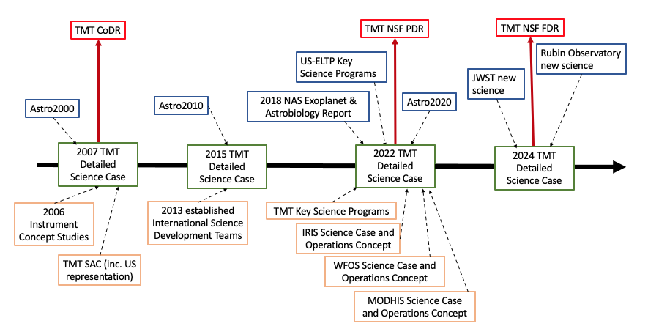
Figure 2-1: Timeline of the inputs and revisions of the TMT Detailed Science Case.
Although the science cases within the DSC reflect a very large community effort to understand current and future science needs, they should be seen as very useful and necessary exemplars. It is not possible to predict the burning questions that will be dominating astronomy in the next ten, let alone fifty years, and history has shown that facilities designed for specific science cases generally produce compelling science well beyond their originating sets. These science exemplars, then, push the boundaries of the TMT design into as broad a region of discovery space as possible. TMT is designed as an observatory and not an experiment. The scientific mission of TMT will evolve over its expected lifetime of fifty years, and the observatory must provide sufficient flexibility and multi-use capabilities to be in a position to pursue an evolving set of science goals. Nonetheless, we need the exemplars to motivate the design and ensure TMT is designed to do specific science well with the faith and knowledge that clever future users will be able to employ the observatory to reach their future goals as well.

Science Flowdown Process
TMT’s Detailed Science Case (RD1) not only describes examples of the groundbreaking astronomy enabled by TMT, it describes the capabilities (modes, instruments, and AO facilities) that provide for the needed observations. This description forms the basis for the flow from science cases to subsystem requirements. Figure 3-1 schematically illustrates the TMT science flowdown process, starting with the big questions that kickoff the DSC and ending with subsystem (level 2) design requirements.
The flowdown process is systematic. Within the DSC, the big questions inspire the science cases. The science cases generate a set of key design parameters through an iterative optimization process that translates the science cases into observing programs (Section 3.2). These observing programs prompt requirements on science and operations (Section 3.3), which in turn flow into system level and subsystem requirements (Section 3.4). Throughout the top-down requirements development, the links to the level above are maintained so each final subsystem requirement can be traced to every previous step all the way back to the big questions and its motivating science case.
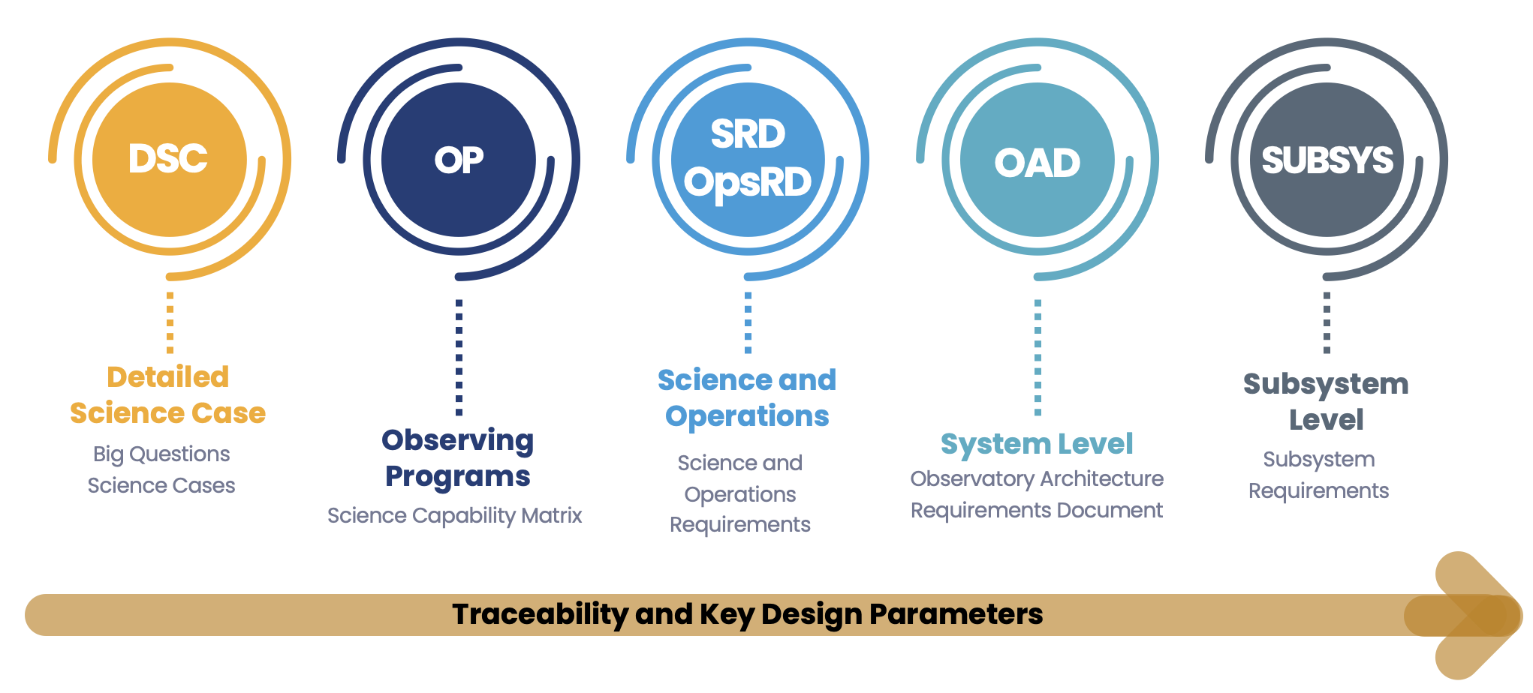
Figure 3-1: TMT Science Flowdown Process.

Identifying Observing Capabilities, AO Facilities, and Instruments to Support the Motivating Science Cases
The DSC (RD1) identifies the observing capabilities and modes sufficient for each of the motivating science cases and their related science areas. Although it maps these needed capabilities and modes to the planned TMT instrument suite, that mapping is the result of an unseen iterative optimization process that explored many different ways to meet the science case needs before arriving at the planned first-generation instrument suite and observing modes shown in that mapping.
The choice of TMT’s aperture dimension illustrates the optimization process. Ultimately, TMT's 30-meter diameter was chosen as a sweet spot for maximizing science capability and technical performance with a manageable cost and risk. In principle, science capability grows with a certain power of the telescope's diameter. For example, diffraction-limited resolution grows as D, the science value of seeing-limited observations increases as D², and the sensitivity of many diffraction-limited science cases grows as D⁴. This argument pushes us towards as large a telescope as possible.
However, technical performance becomes more difficult, expensive, and risky to achieve with increasing telescope size. For example, as aperture increases, the Strehl ratio achievable by the AO system decreases, seeing-limited instruments become larger and hence more complicated, riskier, and expensive, and the telescope structure becomes less stiff with lower natural frequencies making it more difficult to control. These arguments push towards a smaller aperture. In the end, our studies showed that TMT at 30 meters can achieve the needed telescope performance with buildable instruments and AO systems. The optimization process becomes a bit harder when there are multiple ways to make a scientific observation and multiple ways to combine capabilities in different instruments, but the general approach is the same and is described in more detail in Section 3.2. Table 3-1 illustrates how TMT’s instruments and observing modes meet, respond to, or provide for the key design features required to address the motivating science cases. The yellow-shaded cells in Table 3-1 highlight the capabilities most important for each mode as TMT is optimized to enable the most gain in each observing mode.

Table 3-1: The key design parameters of the observatory and how they are implemented in each observing mode.
 |  | Observing Mode/First Light and First Decade Instruments
 |  | Seeing-Limited | NGSAO | LGS MCAO | MOAO | ExAO | MIRAO
Design Parameter/Baseline |  | WFOS, HROS | NFIRAOS +  IRIS or MODHIS | NFIRAOS +  IRIS or MODHIS | IRMOS | PSI | MICHI
Pupil Diameter (D) | 30 m | Signal to noise gains as D² | Signal to noise gains as D⁴ |  | Signal to noise gains as D⁴ | Signal to noise gains as D⁴ | Signal to noise gains as D⁴
Throughput/  Emissivity | Telescope: High -dependent throughput;  Emissivity 7% from a 273 K blackbody | Higher throughput maintains signal gain relative to existing 8–10 m observatories | Higher throughput avoids photon starvation in fine-image dissection cases. Poorer emissivity reduces signal to noise per unit observation time |  |  |  | Lower emissivity increases signal to noise per unit observation time
Image Quality | Seeing-Limited median PSS_{N} degradation < 15% with  r_{o} = 20 cm;  High Strehl in AO modes;  ExAO Contrast of 10⁻⁸ | Better image quality results in signal gain through 0.75 arcsec slit. | Science cases based on 156 nm RMS WFE on axis at TMT First Light.  Shorter exposure times, crowded-field spatial resolution | Science cases based on 193 nm RMS WFE on axis at TMT First Light;  Shorter exposure times, crowded-field spatial resolution | Diffraction-limited spatial resolution of targets selected from within a 5 arcmin diameter field | Science based on contrast of 10⁻⁸ at 50 mas, increased science if 10⁻⁹ at 100 mas.  Better contrast yields improved detection of objects | Science case based on 500 nm over field, increased science if 300 nm.  Better image quality results in shorter exposure times
Resulting Sensitivity  (1/time of observation)  = Throughput;  S = Strehl Ratio;  D = Entrance Pupil Diameter | High throughput;  High Strehl;  Large aperture | S/N=150 for V=20.5 in 5x900s at R=3500 for WFOS | S/N=100 for K=25.6 in 1 hr with NFIRAOS+IRIS Imager,  S/N=10 for K=24.2 in 900 s at R=8000 with NFIRAOS+IRIS IFS
Spatial Resolution  = wavelength  mas = milli-arcsec | Excellent site, Airy disk size based on pupil diameter  (1.22 /D) for AO modes | Median seeing  r_{o} = 20 cm.  Better resolution increases ability to discriminate objects | 8 mas @  = 1 m |  | 8 mas @  = 1 m | 17 mas @  = 2 m | 67 mas @  = 8 m
Wavelength Range | 0.34 to 28 µm,  [goal: 0.31 to 28 µm] | Science cases require 0.34–1 µm [goal: 0.31-0.34],  Maximum wavelength coverage increases ability to capture spectral features | Science cases require  0.84–2.4 µm (IRIS)  0.95–2.4 µm (MODHIS) |  | Science cases require  0.84–2.4 µm | Science cases require  2–5.3 µm, increased science with upgrade for 0.6–1.8 µm | Science cases require 3–14 µm, increased science with  3–28 µm
Filled Aperture | Maximum 4% obscuration from secondary mirror and its supports;  Maximum 0.6% obscuration due to M1 segment gaps | Sparser aperture increases pupil/grating sizes within instrument, resulting in higher cost or lower achievable resolution | Minimum structure in PSF yields scientific gains in data reduction.  Increased energy in central core improves SNR |  |  | Minimum structure and compact PSF enable detection of planets closer to host star | Minimum structure in PSF yields scientific gains in data reduction.  Increased energy in central core improves SNR
Articulated M3 | All instruments online,  Switch in 10 minutes | Enables optimized observing for conditions, targets of opportunity and transient programs |  |  | Optimized observing for conditions enables significant gain in science |  | Optimized observing for conditions enables significant gain in science
Nasmyth Platforms | Large and stable platforms, accommodate entire First Decade instrument suite addressable by M3 | High instrument stability of large instruments enables precise radial velocity measurements and consistent image quality | Fixed gravity vector and low vibration required to maximize spectroscopic efficiency and reach precision radial velocities of 30 cm/s |  | Low vibration, significant space envelope and a highly stable environment | Lower vibration increases PSI instrument performance | Fixed gravity vector and low vibration increase spectroscopic efficiency enabling measurement of radial velocities of 1 m/s
Field of View | Telescope 20 arcmin (15 arcmin unvignetted) diameter | WFOS requires 25  (8.3 x 3) arcmin² area,  HROS multi-object spectroscopy 10-20 arcmin in diameter | 10 arcsec diameter field of regard (MODHIS);  34 x 34 arcsec (IRIS imager) |  | 5 arcmin diameter | 1.2 arcsec², increased science if 2 arcsec² | 24 arcsec² L and M bands imager  28 arcsec² N band imager,  2-arcsec slit length high-res spectrometer,  20-arcsec slit length low-res spectrometer
Multiple Laser Guide Stars | Redefinable asterism, up to 8 sodium beacons, with 25 W per beacon | Enhanced seeing with GLAO | N/A | Increased sky coverage at required image quality and uniformity |  | N/A | Increased sky coverage at required image quality
Science Overheads (Observing efficiency for large programs, especially short exposures with many pointings) | Maximum of 5 minutes between end of one observation and start of another with same instrument;  Maximum 10 minutes with change of instruments. | Science programs of 1,000 pointings with observations of 3,600 seconds each (WFOS),  2,500 pointings of 10,800 seconds each (HROS) | Science programs of 600 pointings  with observations of 3,600 seconds each |  | Science programs of 150 pointings with observations  of 14400 seconds each | Science programs of 1,900 pointings with observations  of 3,600 seconds each | Science programs of 600 pointings with observations of 3,600 seconds each

Science Case Decomposition into Observing Programs
The full optimization process from the science case leading to key design parameters starts by decomposing the DSC science cases into observing programs, documented in the Science Capabilities Matrix (RD3). Each observing program uses a single instrument mode, so there are typically multiple defined observing programs per science case. TMT’s International Science Development Teams, along with the instrument science teams, the TMT Science Advisory Committee, external experts, members of the broader TMT science community, and staff scientists contributed to the development of the observing programs. The majority of those providing technical information for observing programs were the original contributors of the science cases in the DSC, and where that was not the case, technical input was provided by subject matter experts.
Figure 3-2 shows a small excerpt (cut both in rows and columns) of the observing program description contained in TMT’s requirements management system, DOORS, and documented in the Science Capabilities Matrix. Additional unshown columns include more observing parameters for each program such as wavelength range, spectral and spatial resolution, field of view, number of targets in the program, number of targets per observation, integration time, and so on. The intent is not to fully describe each observation, but to create a common framework in which their implications can be better understood as a whole. Table A-1 in Appendix A describes each Science Capabilities Matrix parameter in detail.
This matrix allows for the iterative optimizations used to determine the observatory’s set of instruments, operating modes, and key design parameters. The ensuing requirements derive from the optimized extreme values of these key design parameters.
Figure 3-2: An excerpt of the Science Capabilities Matrix in DOORS showing a subset of the fields that describe each observing program

Observing Program Flowdown into Level 0 Requirements
The key design parameters derived from the observing programs feed TMT’s two top-level (Level 0) requirements documents: the Science Requirements Document (SRD, RD2), and the Operations Requirements Document (OpsRD, RD4). The SRD captures the requirements that respond directly to the technical performance demanded by the observing programs, while the OpsRD captures requirements necessary to ensure efficient operations that support the science programs. Each requirement has a unique identifier that enables full traceability. At each milestone where the DSC is updated (Figure 2-1), the SRD and OpsRD are also updated, following TMT’s configuration management process (RD6), to ensure consistency and continuity of traceability.
Figure 3-3 is an excerpt from the Science Capabilities Matrix in DOORS and highlights two specific requirements to illustrate how it is traced to level 0 requirements.
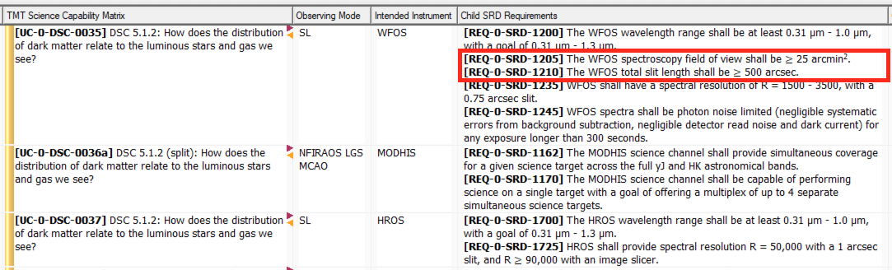
Figure 3-3: An excerpt of the Science Capabilities Matrix flowdown to Level 0 Requirements in DOORS

Level 0 Requirement Flowdown to System and Subsystem Requirements
The SRD and OpsRD Level 0 requirements are decomposed and flowed down to system level requirements (Level 1) in the Observatory Architecture Document (OAD, RD9). The OAD describes the technical requirements and observatory architecture that will allow TMT to meet its science and operational expectations and potential. The OAD is the key document from which all subsystem level requirements (Level 2 and below) flow as needed to define the performance and functionality of all of TMT’s subsystems. The full functional decomposition of TMT into subsystems is described in the TMT Systems Engineering Management Plan (RD8).
Figure 3-4 shows an excerpt from the SRD showing the same requirements as in Figure 3-3 (with the square highlighting at the left of the figure), illustrating their traceability to higher and lower levels.
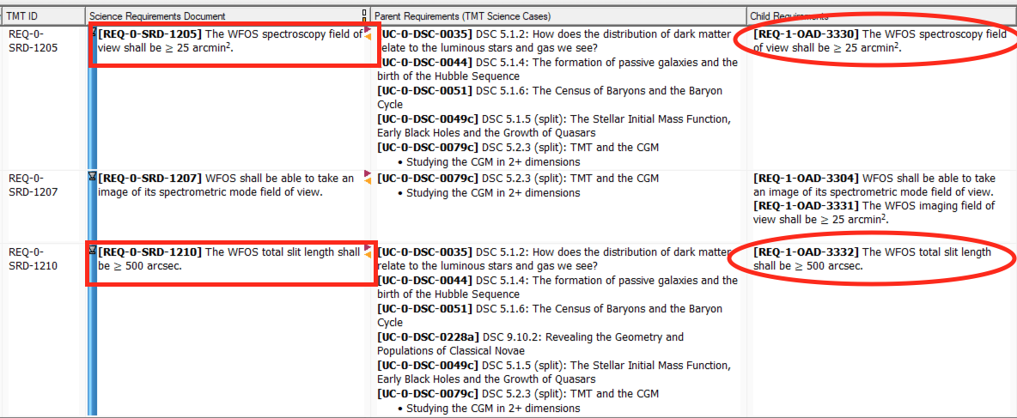
Figure 3-4: An excerpt of the same requirement as in Figure 3-3 in the SRD, flowing to a level 1 OAD requirement and illustrating the traceability to higher and lower levels
Figure 3-5 shows an excerpt from the OAD and how it is traced down to Level 2 subsystem requirements in DOORS, as well as back up to parent (Level 0) requirements.
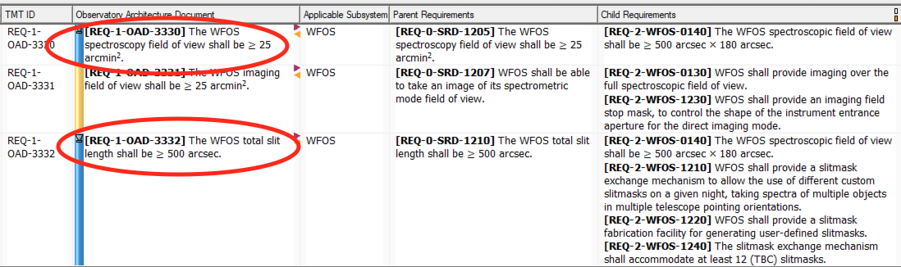
Figure 3-5: An excerpt showing the same requirement as in Figure 3-4 in the OAD flowing to level 2 requirements and illustrating the traceability to higher and lower levels

Traceability Visualization
The figures in Section 3.4 illustrate the full traceability that exists in DOORS from the science cases all the way to the lower level subsystem requirements. This traceability is easily viewed in a graphical format with TraceTree, a DOORS read-only visualization tool.
Figure 3-6 shows an example TraceTree output for a single observing program from a TMT science case. The science case reflects an Astro2020 science case and leads (from left to right) to the observing program (yellow), to SRD requirements (light pink), and to OAD requirements (dark pink), where the requirement is further broken down to the level 2 subsystems (orange) and level 3 components (green). Boxes with thick red borders indicate the requirement is tagged as a Key Performance Parameter (KPP), discussed in Section 4. Within TraceTree, clicking on each linked item leads to more details, making it easy to explore and trace its full set of parent and child relationships. Additional KPP TraceTree diagrams can be found in Appendix B.

Due to the interconnectivity of some of the KPPs, some of the level 1 requirements are decomposed to more detailed or specific level 1 requirements in the OAD to ease the traceability and flow down to level 2 subsystem requirements.
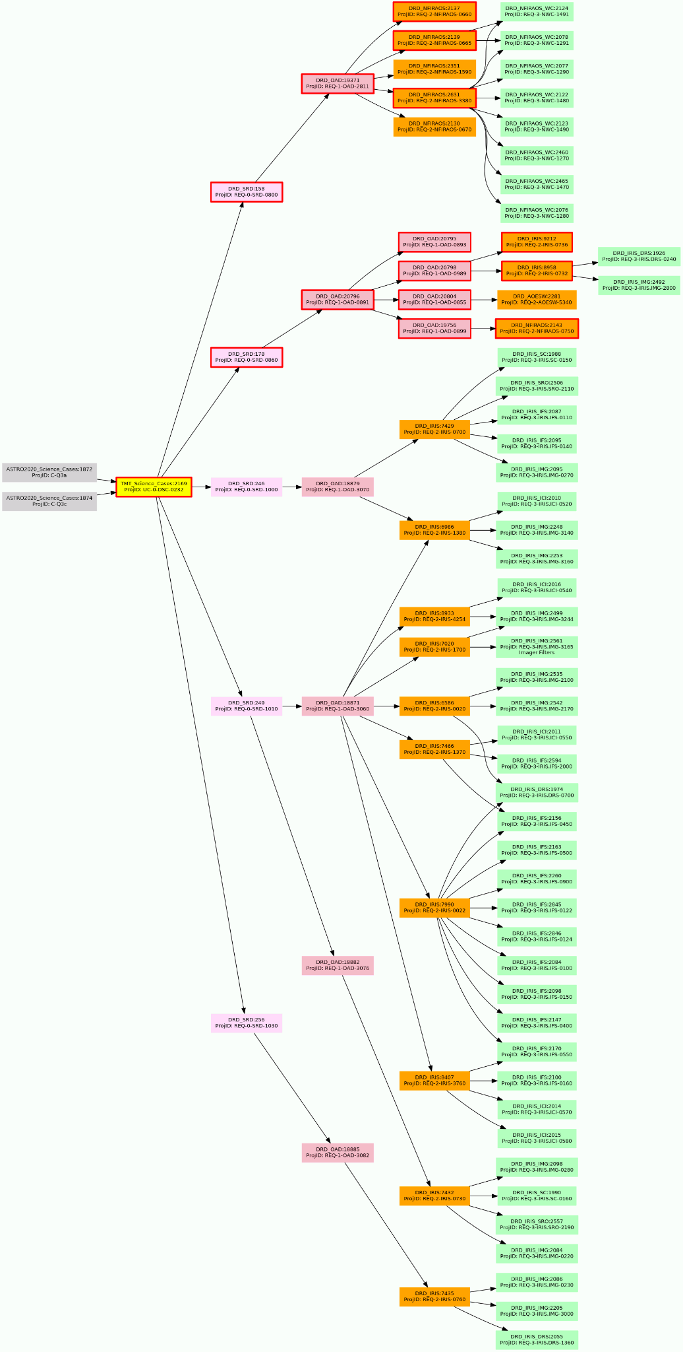

Figure 3-6: A visual illustration from TraceTree showing the flow of a TMT Science Case/Observing program (UC-0-DSC-0232) to all of its flowdown requirements. Thick red outline shows the KPP performance requirements described in Section 4.

Key Performance Relative to Driving Science Cases
Once the science cases have been broken into observing programs described by key design parameters and optimized as a set of matched capabilities, Key Performance Parameters (KPPs) are defined to measure and track performance. Each KPP is a primary technical metric (such as image quality, throughput, etc.) used to measure system performance. KPPs are divided and allocated to subsystems, and tracked at regular reviews, providing a snapshot of system performance and requirements compliance. Because the KPPs are linked to their driving science cases and through the traceability between all observing programs and system and subsystem requirements, it is straight-forward to understand the implications of changing a science case or adjusting the value of a KPP.
The key parameters that influence the performance of TMT are: aperture size, PSF shape, throughput, emissivity, image quality, AO Strehl Ratio, spatial resolution, wavelength range and resolution, field of view, sky coverage provided by NGS and LGS AO, contrast ratio and inner working angle, instrument stability, and efficiency of operations including the time to switch between observations.
We formally define driving science cases as those that address a well-defined, high-profile but narrow topic that are used to set the design requirements that relate to a particular KPP. Science cases with close, but not quite as stringent a constraint, may also be marked as driving cases so they can be considered when investigating small adjustments to KPP values.

Key Performance Parameter Flowdown Analysis
Requirements related to KPPs are tagged in DOORS, facilitating analyses to:
- Show that the flowdown is complete,
- Find the optimal allocation balance between subsystems, and
- Identify the impacts if a subsystem experiences difficulty meeting its allocation.
KPPs are tagged only for performance requirements, and not for any corresponding functional requirements, since the purpose is to aid in understanding performance and its impacts from the science drivers to the subsystem design.
TraceTree provides visibility of the KPP traceability as shown in Figure 4-1 and Figure 4-2. The first figure shows a single high level requirement with multiple science case parents and Astro2020 grandparents. Entries bordered by thick black lines indicate driving science cases while those with thick red boxes drive the relevant KPPs. In this particular case, the highlighted yellow requirement (REQ-0-SRD-0870) is a level 1 astrometric precision requirement. The visualization clearly shows this requirement affects many science cases and feeds many lower level requirements in turn. In these complex cases, it is particularly useful to focus on the driving requirements, highlighted by the bold outer borders. In this case, it’s clear only a subset of the parent science cases are drivers.
Figure 4-2 shows a different example in which multiple science cases feed multiple top-level requirements, leading to a single level 1 requirement, in this case one on astrometry, that in turn flows to multiple lower level requirements. Although only shown as requirement IDs here, within TraceTree it is easy to expand the display, or click on an entry, to reveal the requirement text and related information.
Figure 4-3 is an example of how we note the interconnectivity of KPPs. Often, the key performance areas of the Observatory do not act in isolation. There are connections between some of the KPPs, which can either complement or degrade performance. For example, vibration is connected to point source sensitivity, which is connected to AO wavefront error. If vibration requirements are not achieved, then there is a possibility of not meeting AO wavefront error or point source sensitivity requirements. By flagging the KPP requirements in DOORS, the interconnected KPPs can be tracked and analyzed to determine how they affect each other, as shown in Figure 4-3.
Appendix B contains flow diagrams for additional KPPs, showing only the requirements that drive each value.

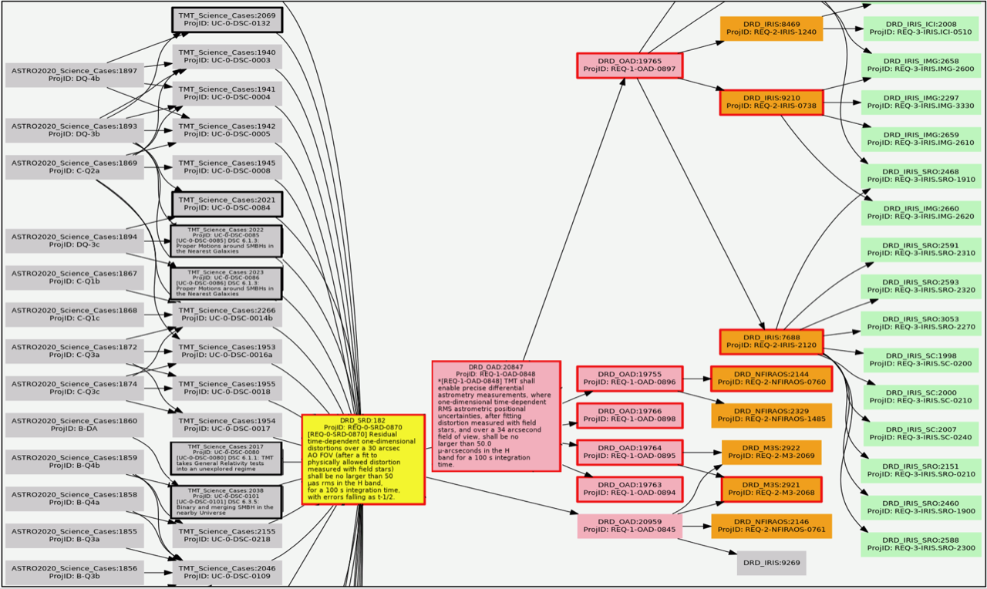
Figure 4-1: A visual representation showing some of the science cases for a single high-level requirement (for this example there are 26 related science cases of which 12 are shown). Thick black outlines indicate the driving science cases (3 are seen and there are a total of 6 for this particular requirement). Thick red outlines highlight the KPP drivers.

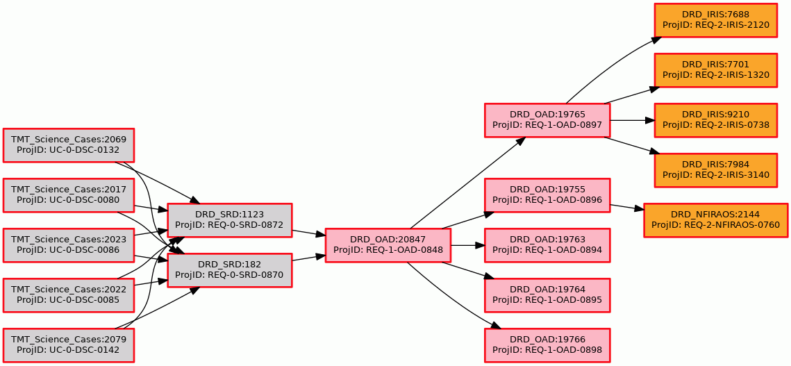
Figure 4-2: The astrometry KPP flow from TraceTree. Thick red outlines highlight the KPP drivers.

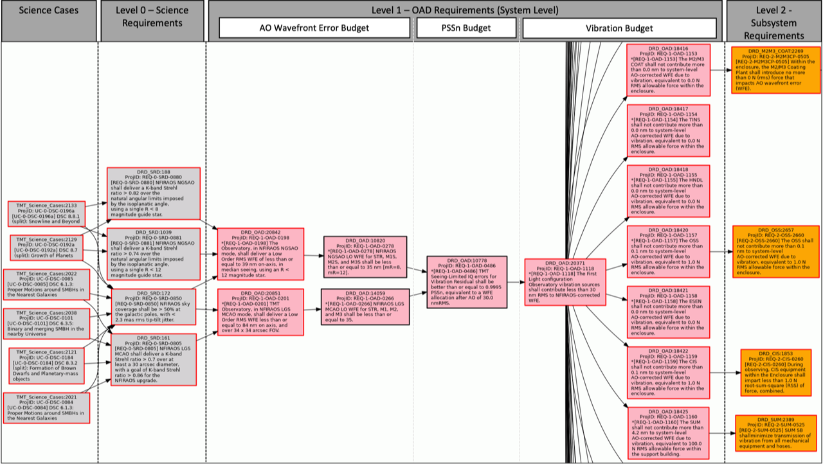
Figure 4-3: A TraceTree diagram for interconnected KPPs

Key Performance Parameter Tracking
KPPs are monitored and controlled by comparing the requirements to Current Best Estimates (CBEs) in an activity referred to as Technical Performance Measurement. TMT actively manages KPPs to identify and resolve issues early in the process to minimize budget and schedule impacts.
When a technical budget is reviewed, the current best estimate for each KPP is recorded as part of that budget release. Design teams use methods such as modeling and simulations, prototype testing, and historical data to predict performance. This permits CBE tracking and monitoring as a function of time. Of note is the remaining margin, the difference between the requirement allocation and the CBE. If the remaining margin becomes unacceptably small, corrective actions (such as studies to explore re-allocation of system resources, release of reserve, and/or observatory-level trade studies) are considered and implemented as appropriate.
Figure 4-4 shows an example of the Technical Performance Measurement of the TMT Vibration Budget. The charts on the left show how the total allocations for different areas of TMT (e.g. on the Telescope, inside the Support Building) have evolved with the releases of the budget. The charts on the right track the observatory total allocation (CBE) alongside the requirement at each of the releases. The first column of Table 5-1 below contains the list of KPPs that are actively monitored and managed.
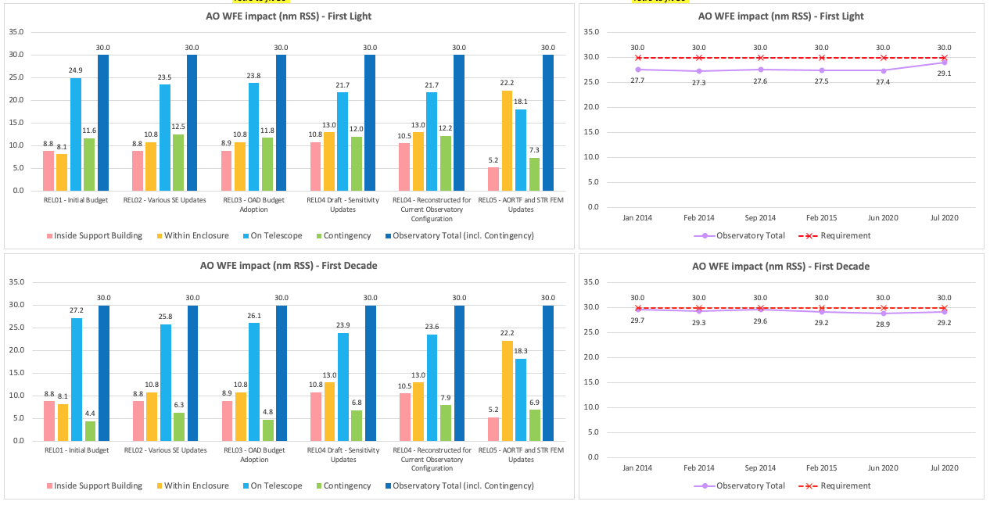
Figure 4-4: A snapshot of the time series of the technical performance measurement for the vibration KPP

Driving Science Cases
The clear flowdown and traceability from science to requirements provides insight into how the design decisions in each subsystem will impact the overall performance of the observatory. The careful definition and management of system level KPPs and budgets allows the team to refine estimates as designs mature and proactively identify areas of concern that may need additional analysis or resources.
Table 5-1 takes advantage of the full science case to requirement flowdown, and the tracking of KPPs and their drivers, to connect each KPP to their driving science cases. This connection is useful when considering changes in science cases or KPP values as the design of, and environment around, TMT evolve. If a science case changes, or a KPP proves hard to meet, these connections promote informed decisions about possible compromises and scientific prioritization.
As an example of reading the table, the value of the Acquisition Time: Adaptive Optics KPP (first column) is driven by the observing program UC-0-DSC-0217 (Target of Opportunity; second column). This program has the most stringent constraint on the KPP (5 minutes; 4th column) and derives from the DSC science case 9.7 (Probing The High-z Universe with Gamma-ray Bursts; 3rd column). This requirement in turn flows to the SRD and OpsRD requirements listed in column 5, leading ultimately to the final system requirement provided in column 6.
Some KPPs are not connected to driving science cases, but are critical to observatory performance and operational efficiency and are thus tracked similarly. These KPPs include Maintenance Time, Mass, Reliability, and Services.

Table 5-1: Driving science cases
Key Performance Parameter | Driving Science Case ID | Driving Science Case/ Observing Program | Driving Science Case Performance | Requirement ID | Requirement
Preset Time,  Acquisition Time: AO  (PRESET, ACQAO) | UC-0-DSC-0217 | DSC 9.7: Probing The High-z Universe with Gamma-ray Bursts | 5 min. | REQ-0-SRD-0200  REQ-0-OPSRD-3022  REQ-0-OPSRD-3024 | Preset in less than 3 minutes  Acquisition in less than  5 minutes  Acquisition in less than 10  minutes w/ major instrument  change
 | UC-0-DSC-0082  UC-0-DSC-0083 | DSC 6.1.2: How the GC black hole interacts with its unusual environment | < 1 hr (30 min. goal) (inc. decision overheads)
Preset Time, Acquisition Time: Seeing Limited  (PRESET, ACQSL) | UC-0-DSC-0110 | DSC 6.5: Time variability, probing the structure and processes in the central engine [AGN] | < 1 hr (inc. decision overheads¹)
 | UC-0-DSC-0209 | DSC 9.2: Identifying The Shock Breakout of Core-Collapse Supernovae | < 1 hr (inc. decision overheads¹)
Astrometric Precision, AO  (ASTR) | UC-0-DSC-0080 | DSC 6.1.1: TMT takes General Relativity tests into an unexplored regime [Milky Way GC, Sgr A*] | 50 µas (for 20 yr baseline), t = 100 s (multiple 1 s exposures) | REQ-0-SRD-0870  REQ-0-SRD-0872 | 50 µas (t/100 s)^{-1/2}  10 µas systematic floor
 | UC-0-DSC-0085  UC-0-DSC-0086 | DSC 6.1.3: Proper Motions around SMBHs in the Nearest Galaxies | 50 µas, t = 100 s (goal 15 µas in 600 s)
 | UC-0-DSC-0132 | DSC 7.6.2: Internal dynamics of dwarf-spheroidal galaxies: density profiles of dark matter halo | 50 µas, t = 100 s
 | UC-0-DSC-0142 | DSC 7.6.6: Velocity anisotropy of distant Milky Way halo: evidence of accretion event | 20 µas, t = 1600 s
Photometric Precision: Absolute, AO  (PHOTA) | UC-0-DSC-0159 | DSC 7.8.6: Time-resolved History of the Galaxies in the Local Volume: the TMT Era | 10% (5% goal) | REQ-0-SRD-0865 | 10% (5% goal)
Photometric Precision: Differential, AO  (PHOTD) | UC-0-DSC-0122 | DSC 7.3.2: Globular Clusters: their origin and evolution | 2% (goal 1%) for J, K ~ 26.5 | REQ-0-SRD-0860 | < 2% for 3600 s integration at 1 µm, over 30 arcsec FOV
 | UC-0-DSC-0232 | DSC 9.11: Cepheid Variables in Nearby (D < 50 Mpc) Hosts of SNe Ia | 2% for K < 26.8, t=120 s
 | UC-0-DSC-0233 | DSC 9.11: Cepheid Variables to 10 Mpc RR Lyrae to 1 Mpc | 2% for K < 28 and t~ 3600 s
LGS MCAO Wavefront Error  (MCAO) | UC-0-DSC-0101 | DSC 6.3.5: Binary and Merging SMBH in the Nearby Universe | 70% Strehl K | REQ-0-SRD-0805  REQ-0-SRD-0850 | 70% Strehl K (goal 86%K)  Sky coverage 50% at galactic poles
 | UC-0-DSC-0184 | DSC 8.3.2: Formation of Brown Dwarfs and Planetary-mass Objects | 70% Strehl K
NGSAO Wavefront Error (NGSAO) | UC-0-DSC-0239 | DSC 10.2.2: Exoplanet Imaging at First-Light with NFIRAOS and IRIS of Young Gas-Giants | 82% Strehl K | REQ-0-SRD-0880  REQ-0-SRD-0881  REQ-0-SRD-0850 | 82% Strehl K  (guidestar R < 8)  74% Strehl K  (guidestar R < 12)  Sky coverage 50% at galactic poles
Image Quality, Seeing-Limited (PSSN) | UC-0-DSC-0252  UC-0-DSC-0257a | DSC 11.1.1 and DSC 11.1.4: Asteroid Properties | 60% encircled energy in 0.2” | REQ-0-SRD-0070 | Telescope IQ degradation better than 20%
 | UC-0-DSC-0169 | DSC 8.2.2: Kinematic Evolution (Star Formation) | 95% encircled energy in 0.4”
Image Quality, Seeing-Limited Off-Axis  (PSSNF) | UC-0-DSC-0039 | DSC 5.1.3: The Growth of Stars: Star-Formation Histories, Dust, and Chemical Evolution | 72% encircled energy in 0.2 arcsec | REQ-0-SRD-1220 | Encircled energy > 80% within an angular diameter of 0.25 arcsec on-sky.
 | UC-0-DSC-0121b | DSC 7.3.1: Star cluster formation and evolution and their environmental dependence | 72% encircled energy in 0.2 arcsec | REQ-0-SRD-0070  REQ-0-SRD-1215 | Telescope IQ degradation better than 20%  Image quality no worse than 0.45 arcsec FWHM
AO Pupil Stability  (PUPIL) | UC-0-DSC-0054a | DSC 5.1.1: Morphological and Kinematic Growth of Galaxies: The Build-Up of Galactic Disks | K band R ~ 6000 IFS spectroscopy to K < 29.8 | REQ-0-SRD-0150 | Telescope thermal background < 7% of ambient blackbody
 | UC-0-DSC-0084  UC-0-DSC-0085 | DSC 6.1.3: Proper Motions around SMBHs in the Nearest Galaxies | K band imaging to K < 30
 | UC-0-DSC-0239 | DSC 10.2.2: Exoplanet Imaging at First-Light with NFIRAOS and IRIS of Young Gas-Giants | 82% Strehl K Contrast 6x10⁴ @H
Throughput  (TPUT) | UC-0-DSC-0215 | DSC 9.6: Understanding Progenitors of Gamma-ray Bursts: Connection to Supernovae and Kilonovae | J, H, K ~ 25, R = 1000, t = 10x360 s , SNR†~2 | REQ-0-SRD-0125  REQ-0-SRD-0800  REQ-0-SRD-1080 | M1 reflectivity  NFIRAOS throughput 60% - 80%  IRIS throughput > 30%
 | UC-0-DSC-0160 | DSC 7.8.7: Probing LSB and BCD Galaxies: Star Formation, Chemical Evolution, Dark Matter | K ~24, R = 4000, t = 10x600, SNR^{†2}~2
 | UC-0-DSC-0246a | DSC 10.3.3: High-dispersion spectroscopy and biosignature gasses (Exoplanets) | J,H,K~19, R = 100,000, t = 1x600 s, SNR^{†2}~2 | REQ-0-SRD-0125  REQ-0-SRD-0800  REQ-0-SRD-1180 | M1 reflectivity  NFIRAOS throughput 60% - 80%  MODHIS throughput > 10%
 | UC-0-DSC-0216 | DSC 9.6: Understanding Progenitors of Gamma-ray Bursts: Connection to Supernovae and Kilonovae | griz ~ 26, R=1500, t = 3600, SNR^{†2}~3 | REQ-0-SRD-0125  REQ-0-SRD-1240 | M1 reflectivity  WFOS throughput > 25% - 30%

Appendix A: Science Capabilities Matrix Parameters Definitions
The science capabilities matrix documents TMT’s observing programs. The matrix groups programs into categories, identifies parameters, and provides a framework to understand the observations. The parameters used in the matrix are defined here to unsure a common interpretation and understanding of the parameters to facilitate the iterative optimizations used to determine the observatory’s set of instruments, operating modes, and key design parameters.

Table 6-1: Science Capabilities Matrix Parameter Definitions
Category | Parameter | Definition
General | Observing Mode | SL: Seeing Limited  SL Enhanced: Performance between SL & NGSAO mode  NGSAO: Natural Guide Star Adaptive Optics  MCAO: LGS Multi-Conjugate Adaptive Optics  MOAO: Multi-Object Adaptive Optics  MIRAO: Mid-IR Adaptive Optics  ExAO: Extreme Adaptive Optics  GLAO: Ground Layer Adaptive Optics
 | Intended Instrument | HROS  IRIS IFU  IRIS Imager  IRMOS  MIRES  MODHIS  NIRES-R  PFI  WFOS
 | Required Efficiency | This parameter asks if the efficiency of gathering observations could impact the ability to do science. Does time lost during dithering, setting up the AO, tracking non-sidereal or reading out detectors for example, impact the science? What is the necessary efficiency to complete the science as opposed to the desired operational efficiency?
Target Parameters | Target Magnitude in Required Filter(s) | Continuum or average magnitude of the target in the required wavelength band.
 | AO Guide Target | For a single or individual science target, if the object is smaller than 1.7" in extent it can be used as the guide star in Natural Guide star AO. If the target is a group of individual sources, such as a star cluster, then this parameter is not applicable. An example of an extended science target might be a solar system body such as a moon or asteroid.
 | Minimum Sky Coverage All Sky for AO Assisted Observations (%) | Minimum acceptable sky coverage when carrying out AO assisted observations (if applicable). e.g. 50% at galactic pole. Some modes may not achieve full coverage of the sky, such as NGSAO and the limitation imposed by the spatial density of sufficiently bright guide stars.
 | Target Polarization Level  (%) | Percentage polarization exhibited by the source, either linear or circular. Can be for a point or extended source. This parameter is important for any source that may be partially polarized because the throughput of any instrument, even those that are not polarimeters, has a dependency on polarization. An observing program may not require the measurement of the polarimetric properties of a science target, in fact most observing programs do not require polarimetric measurements, but the photometric or spectrophotometric precision required for an observing program may be limited by the instrumental polarization.
Spectral Parameters | Wavelength of Observation range start, Wavelength of Observation range end  (µm) | Total range of wavelength of interest for the observing program. This may be greater than the wavelength coverage needed for a particular observation, see ‘Required Wavelength Coverage’ below, where a short wavelength range within the total range may be selected.  The total wavelength range of interest should cover the entire wavelength region that would be observed in order to capture the spectral features that would be analyzed, e.g. if there are several emission line features spread over a range that would be best observed simultaneously that entire range should be specified. If the total wavelength range of interest is large, e.g.  1 to 2.4 microns but could be split into separate regions (in this example that might be the J, H and K filters) then the full 1 to 2.4 microns should be specified as the total wavelength range of interest and the width of the smaller separate regions, say 0.4 microns, should be the required wavelength coverage.
 | Spectral Resolution Required | Required spectral resolution to carry out the observing program as given by λ/∆λ. Broadband images have spectral resolutions around 5-6.
 | Spectral: Required Wavelength Coverage (µm) | The actual wavelength range to be covered in a single observation. This can be equal to or a subset of the ‘Total Wavelength Range of Interest’ above. For example, the total wavelength range of interest may be very broad, say 0.32 µm to 1.1 µm, but the required wavelength coverage for a single observation may be much smaller (especially in the case of very high spectral resolution observations for example).
 | Image Quality  (X% of Y arcsec radius for encircled energy) | Percentage of total energy in a specified radius (%/arc sec).
 | Relative or Absolute Flux | All spectroscopic observations require wavelength calibration of sufficient quality to meet the wavelength precision requirements. The relative/absolute definition here refers to flux calibration of either spectroscopic or imaging observations. The distinction between relative and absolute measurements is best illustrated by a few science examples.  Relative flux measurement: Monitoring the light curve of a variable object. Measuring the timescale for these variations only requires differential photometry.  Absolute flux measurement: Supernova flux measurements must be made on an absolute scale to allow fitting of spectral energy distribution templates in multiple bandpasses.  Relative radial velocity measurement: Internal velocity dispersion of a stellar cluster or a galaxy, or the doppler wobble of a star induced by the orbital motion of an exoplanet.  Absolute radial velocity measurement: Mapping very large-scale structures in the IGM.
 | Relative or Absolute Radial Velocity
 | SNR per Resolution Element | This is the required SNR per element where per element can be, e.g. per pixel, per wavelength resolution element, per star after aperture photometry, etc. This is one parameter that can be tested when observations are carried out. The precision parameter (see below) may be sufficient and a formal SNR value unnecessary.
 | Flux or Radial Velocity Reduction Method | How are the photometric measurements or flux calibrated spectra extracted from the raw data?  AP: Aperture photometry with standard dark subtraction and flat fielding  OP: Optimal photometry with standard dark subtraction and flat fielding  SS: Standard spectroscopy  OS: Optimal spectroscopy with profile fitting  CA: Centroid astrometry (center of gravity approach)  PA: Profile astrometry (profile fitting to the stellar PSF)  RDI: Reference star differential imaging  ADI: Angular differential imaging then used with KLIP, LOCI, etc.  S4: Spatial spectral model for speckle suppression  DP: Differential polarimetry  DSP: Differential spectropolarimetry  SDI: Spectral differential imaging  SA: Spectro-astrometry
 | Flux Precision (magnitudes) | Precision is given in magnitudes for flux and in km/s for radial velocity. The 1-sigma photometric precision is essentially ~1.08/(SNR) where SNR is the signal-to-noise ratio in the image. For radial velocity, precision is related to spectral resolution and signal-to-noise and reflects how well the centroid of a spectral feature can be determined. As rule of thumb, spectroscopic precision for a single feature detection roughly goes as ~ (FWHM)/(SNR) where SNR is the signal-to-noise ratio in the spectral feature. Better spectroscopic precision can also be achieved using multiple features or the full cross-correlation of two spectra.
 | Radial Velocity Precision (km/s)
 | Flux or Radial Velocity Stability Timescale | Period over which the required precision must be maintained, and over which systematic errors do not preclude the combined use of independent measurements made during that period. This is the maximum timescale over which an instrument needs to provide the required precision and/or sensitivity. Specifying the Stability Timescale is really important for high precision astrometry and spectroscopy programs where measurements are made over several years (Galactic center stellar motions and exoplanet host star radial velocities).
Spatial Parameters | Required Spatial Sampling  (mas) | For AO-assisted observations, this is the FWHM of the diffraction-limited core of the PSF in milliarcseconds. For seeing-limited observation, this is the Gaussian FWHM of the PSF in milliarcseconds.
 | Image Quality  (Strehl Ratio) | Image quality specifications apply across the required field of view of an observation (see below).  An AO observation of a point source can be described by three parameters: resolution, Strehl ratio and contrast. All three are intricately related, but they are not the same thing. Crudely speaking, an AO PSF has two basic components: a diffraction-limited core and extended wings. Resolution specifies the size of the core and the Strehl ratio gives what fraction of the total light in the PSF is in the core and not in the wings. For an extreme AO instrument like PFI, the background on which this PSF sits is also very important, so a contrast ratio must also be specified. Strehl ratio is not useful to describe seeing-limited programs. The Strehl ratio for an AO-assisted observation is the ratio of the peak of the delivered PSF to the peak of the diffraction-limited PSF. The contrast ratio is the flux ratio between an exoplanet and its parent star.
 | Photometry Type | Required photometric precision and whether this is done using absolute methods with no local standard in the field, or differentially relative to a local flux standard in the field.
 | Photometry Precision (%)
 | For Surveys: Total Area Covered by observation (sq. arcmin) | For a survey program, this is the total area coverage on the sky in arcminutes covered by all the observations in the program.
 | For a Single Observation: Total Area Covered by observation (sq. arcmin) | Area on the sky in square arcminutes covered by a single observation.
 | Distance from Natural Guide Star to Target (arcsec) | This is most important for NGSAO programs when the science target typically needs to be within a distance from the guide star equal to the isoplanatic angle.
 | Field Overlap Between Tiled Observations (from 0-1) | Amount of overlap between two science observations. Allowable values go from 0.0 (no overlap) to 1.0 (single field with no dither). Programs with zero field overlap are typically made up of observations targeting completely different regions of the sky. A value of 0.01 means that observations must be spatially contiguous. A value close to 1.0 denotes a program with small dithers (e.g., Galactic Center program).
 | Spatial Astrometry | The distinction between relative and absolute. A few science examples:  Relative astrometry: Motions of stars around the supermassive black hole at the Galactic center. All measurements are referenced to a single internal grid  Absolute astrometry: Proper motions of Milky Way globular clusters. In this case, multiple grids must be tied into some global reference frame such as the one defined by background quasi-stellar objects.
 | Astrometry Precision Required (mas) | RMS astrometric precision in milliarcsecs
 | Astrometry Stability Timescale (years) | Period over which the required precision must be maintained, and over which systematic errors do not preclude the combined use of independent measurements made during that period.
Multiplexing | Sample Size of Observation(s) | Total number of objects to be observed in order to reach observing program goals
 | Number of Observations | The number of observations here is the number of positions on the sky to be visited as part of the observing program. The sample size divided by the number of observations therefore gives the required multiplexing factor for a given observing program.
Tracking | Sidereal or Non sidereal | Sidereal tracking or not sidereal tracking
Synoptic Signature | ToO Response Time | Time within which science observations must begin after a trigger or alert is received by the observatory.
 | Critical Time Tolerance (hours) | Tolerance on timing of beginning or end of science observations (i.e. integrating on target) for pre-scheduled time critical observations, e.g. for exoplanet transit ingress and egress the tolerance could be 5 minutes from the start or end of observations that are scheduled to span the entire 30 minute ingress/egress with a nominal 15 minutes before and after the start/end of ingress/egress.
 | Baseline  (years) | The total period of time over which the observing program will be carried out. Baselines for TMT observing programs go from days to years.
 | Observations per Baseline | Number of observations in time to be taken over the entire observing program baseline, e.g. 25 observations at 1 per week for 6 calendar months
 | Observation Duration  (seconds) | For non-synoptic programs, this is the total exposure time in seconds that is required at each position on the sky. For synoptic programs, this is the exposure time in seconds of a single time observation.
Polarimetric | Acceptable Polarization Error  (in Ratio: L†% and/or C†%) | The acceptable level of error on the measured polarization fraction in order to do the observing program. Made from a combination of the fundamental measurement error and instrument calibration errors.

Appendix B: Key Performance Parameters (KPP) Diagrams
All of the KPP diagrams are available in TraceTree. Not included in this appendix are the flows for Maintenance Time, Mass, Reliability, and Services.

Science cases (grey) flow down to SRD requirements (grey) to OAD requirements (pink) to level 2 subsystem requirements (orange). Boxes with a thick red boarder indicate it is tagged as a key performance parameter (KPP).
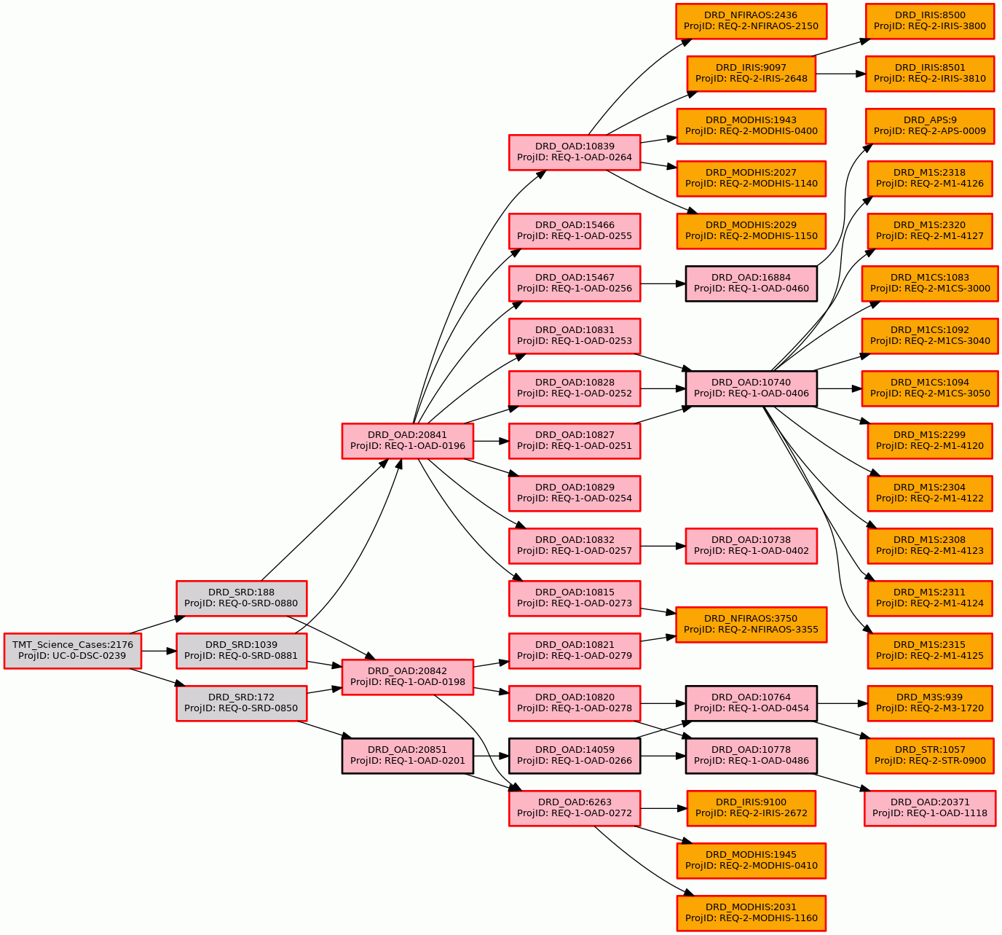
Figure 7-1: Wavefront Error, NFIRAOS NGSAO
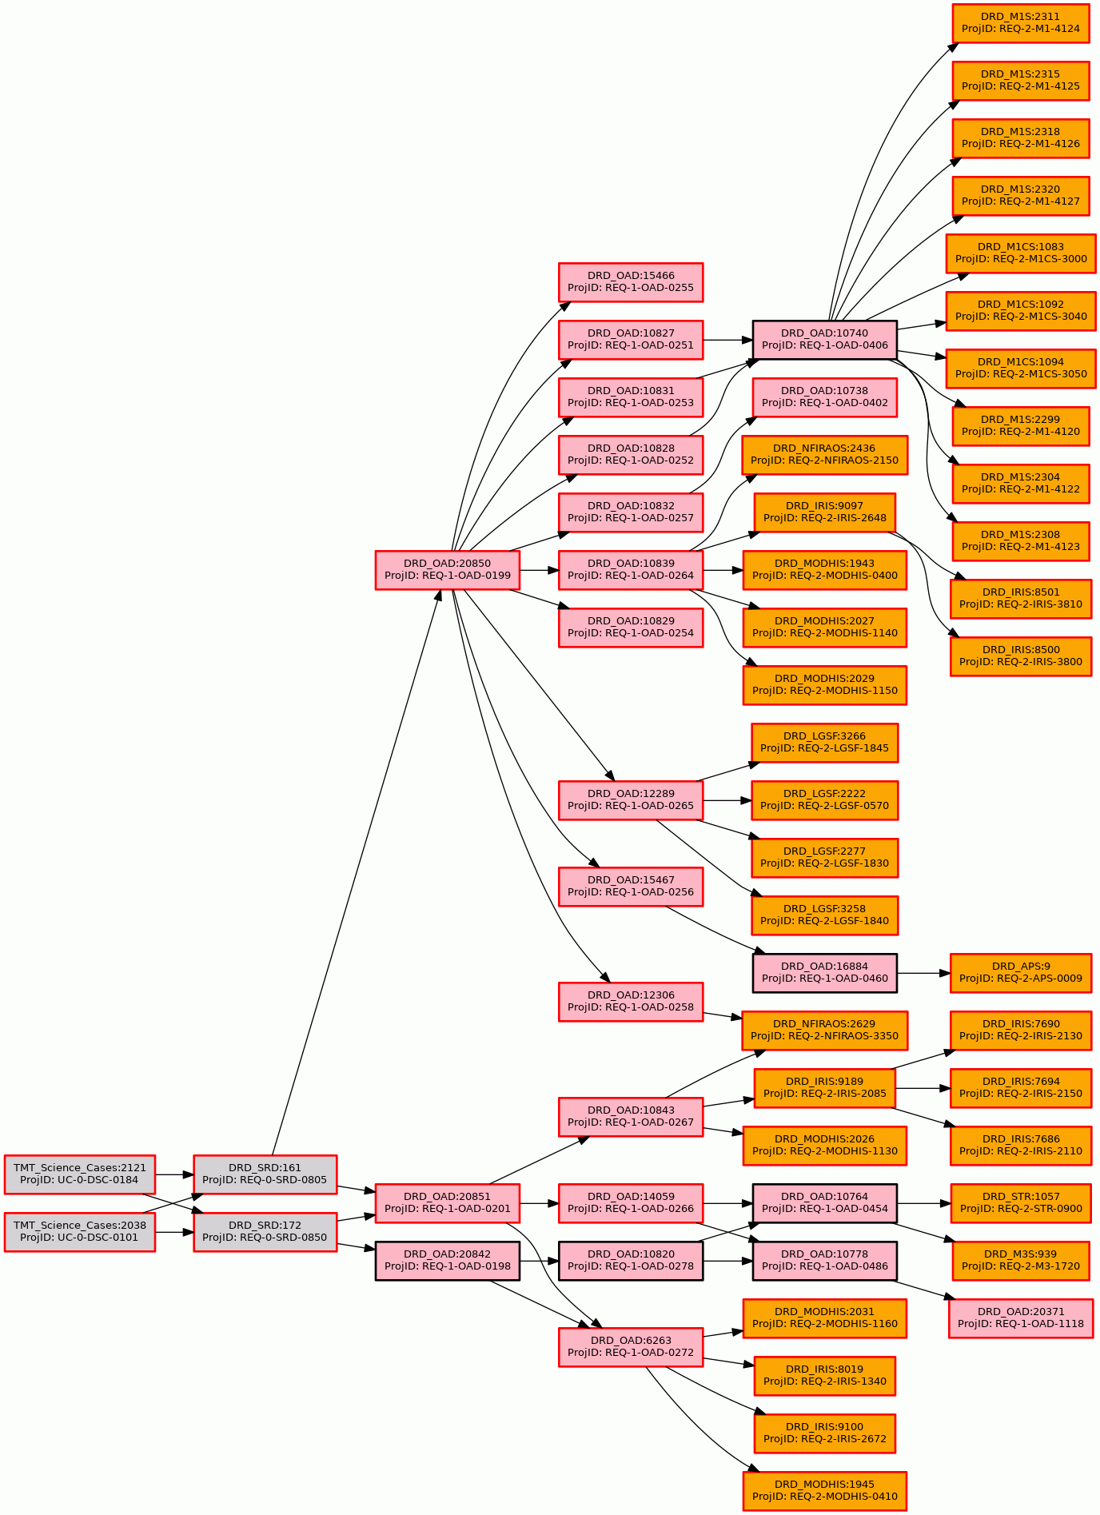
Figure 7-2: Wavefront Error, NFIRAOS LGS MCAO
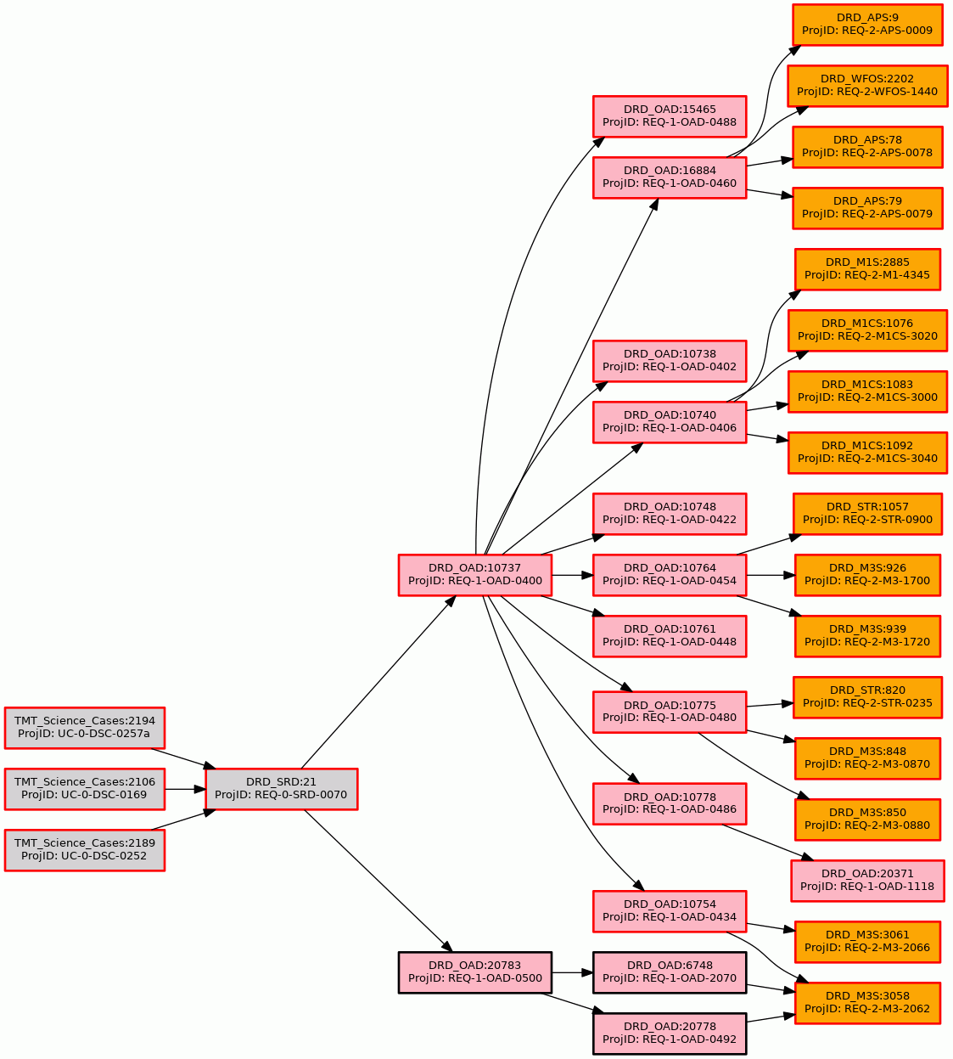
Figure 7-3: Image Quality, Seeing-Limited (PSSN)
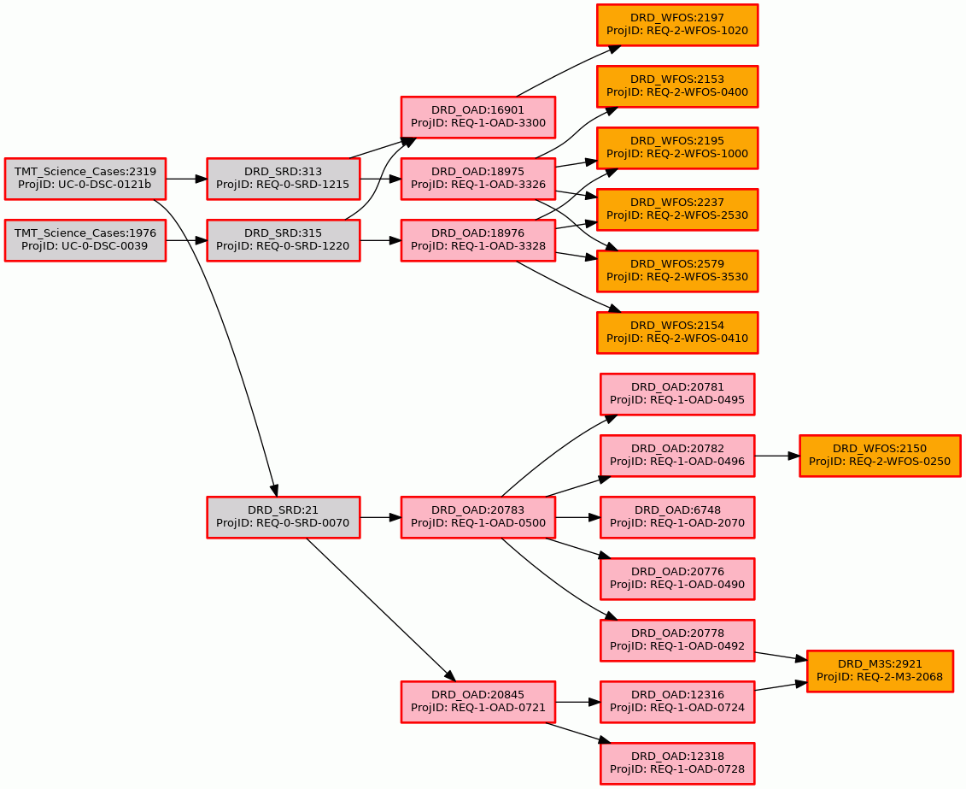
Figure 7-4: Image Quality, Seeing-Limited Off-Axis (PSSNF)
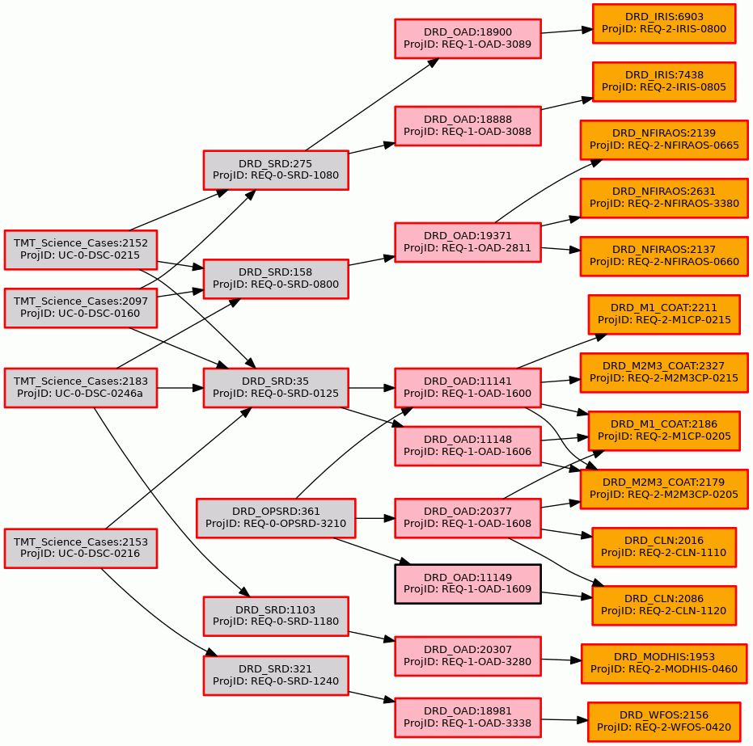
Figure 7-5: Throughput (TPUT)
Figure 7-6: Astrometry (ASTR)

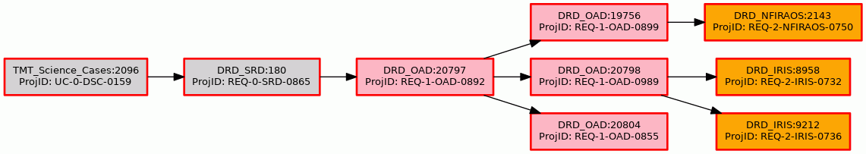
Figure 7-7: Photometry, Absolute (PHOTA)

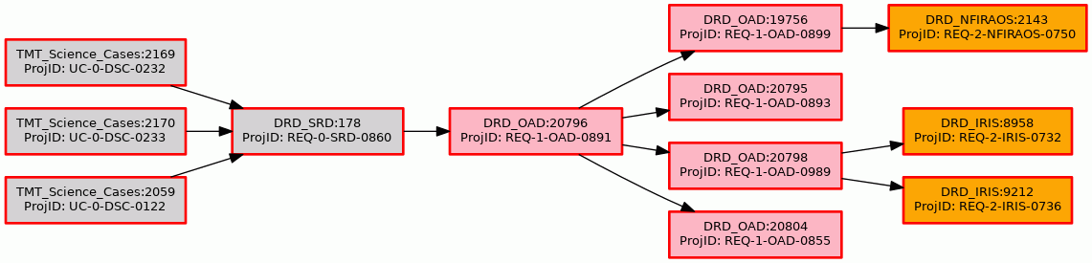
Figure 7-8: Photometry, Differential (PHOTD)
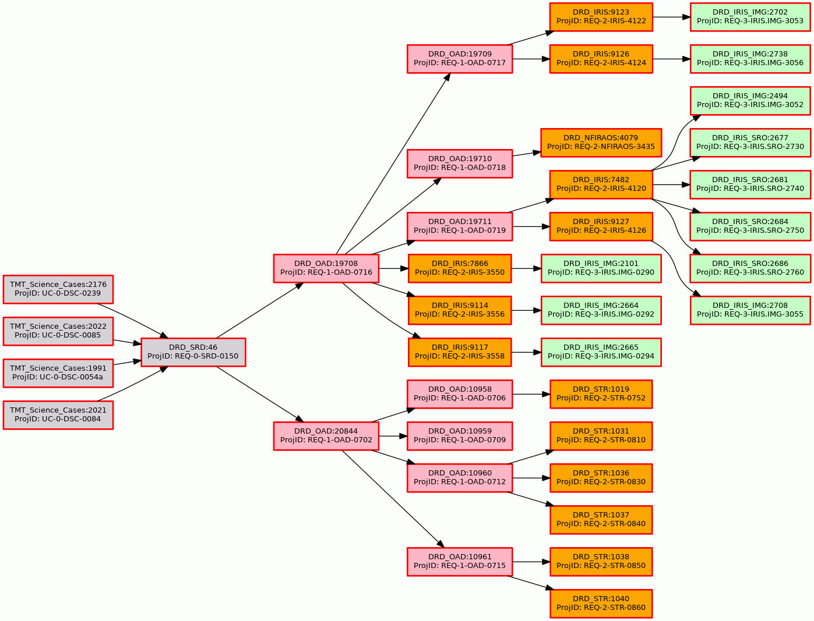
Figure 7-9: Pupil Stability (PUPIL)
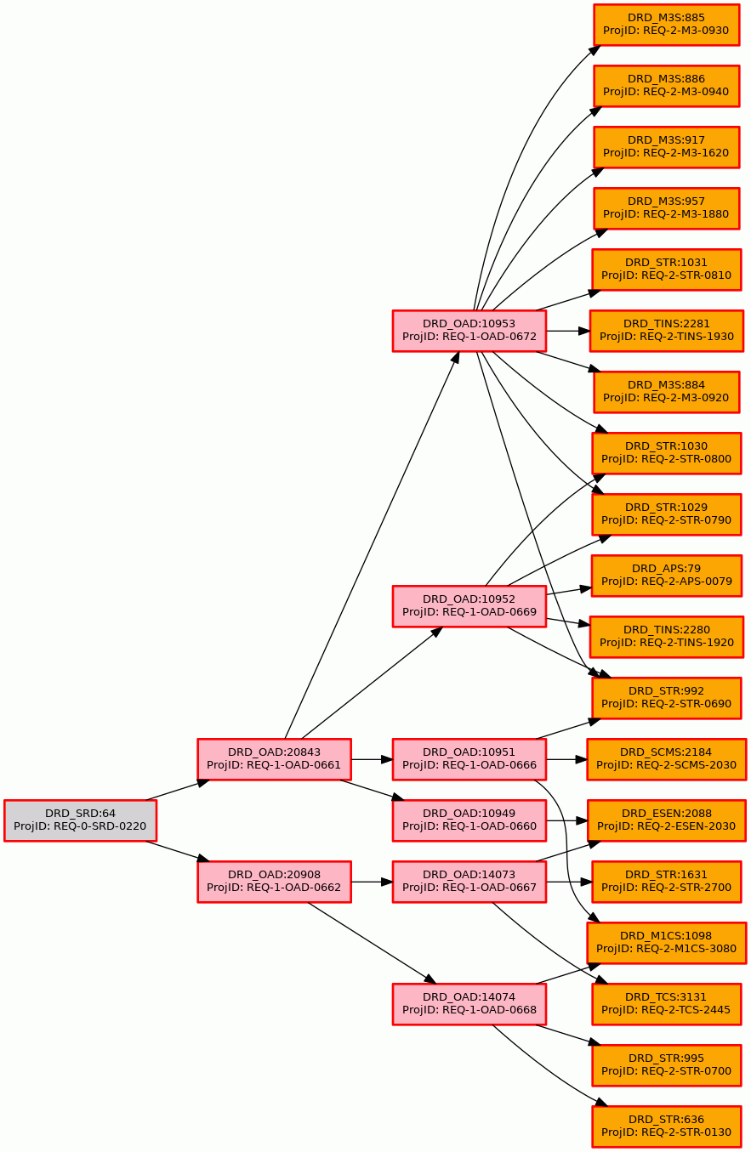
Figure 7-10: Pointing Error (POINT)
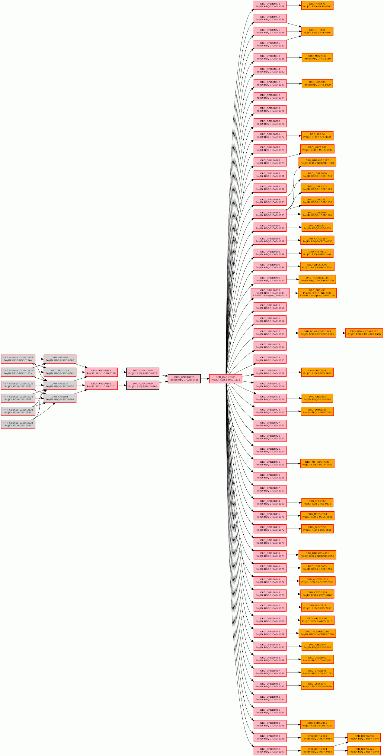
Figure 7-11: Vibration (VIB)
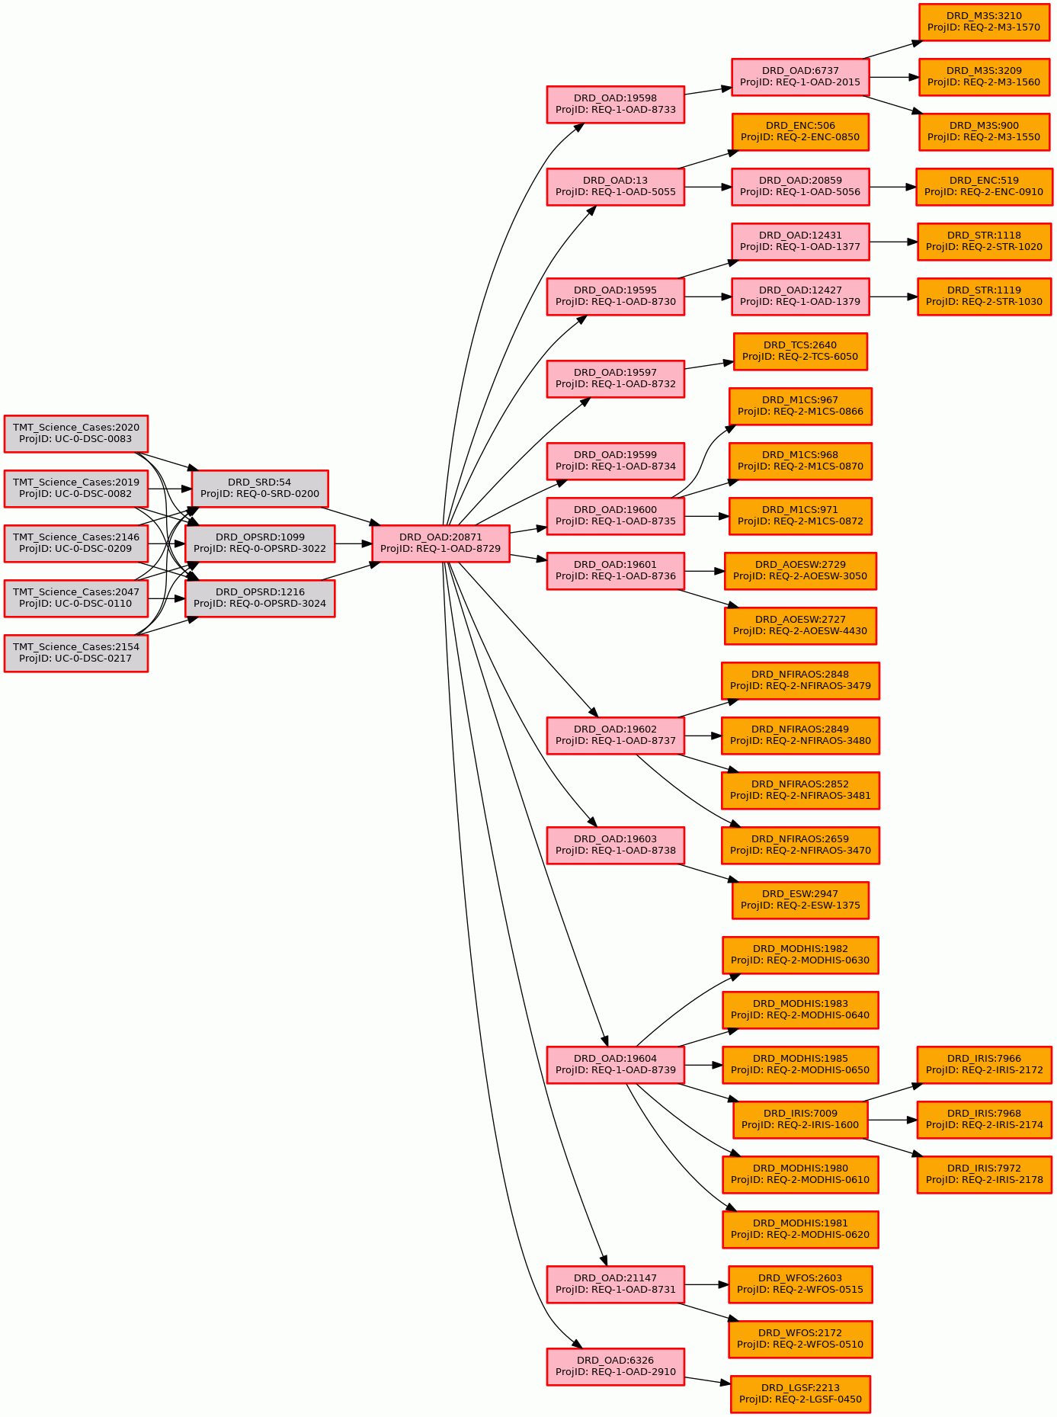
Figure 7-12: Preset Time
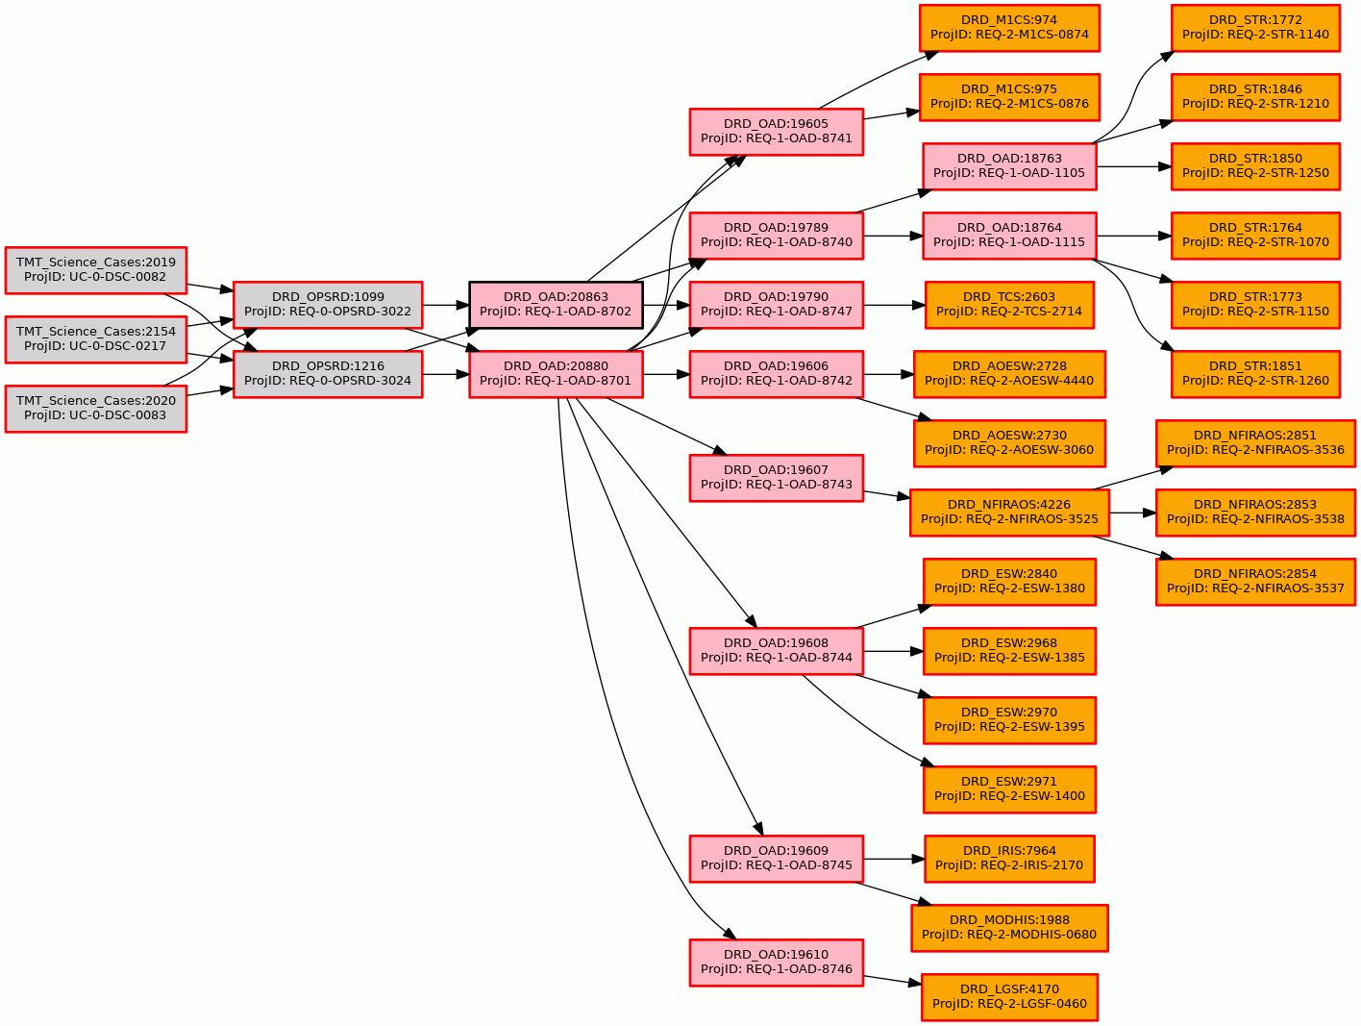
Figure 7-13: Acquisition Time, AO (ACQAO)

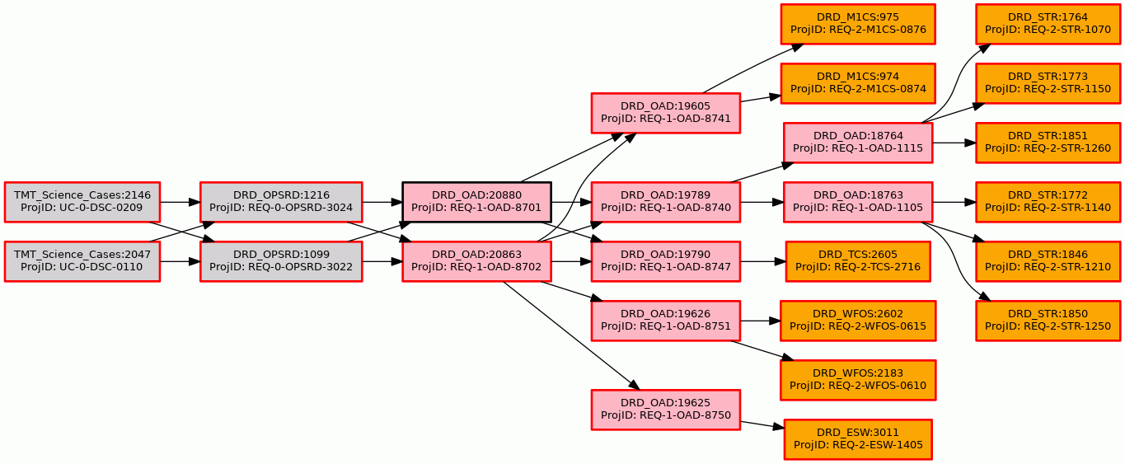
Figure 7-14: Acquisition Time, Seeing-Limited (ACQSL)
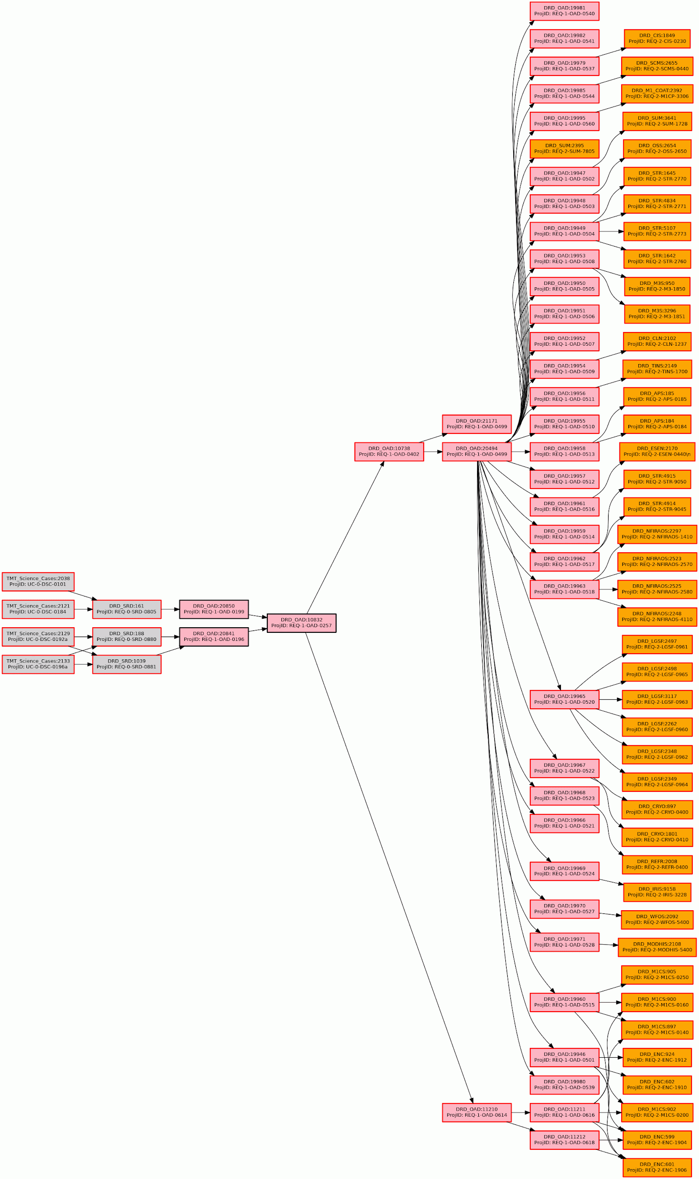
Figure 7-15: Heat Dissipation (HEAT)

Appendix C: Abbreviations

Acronym | Acronym Definition
ACQAO | Acquisition Time, Adaptive Optics (a Key Performance Parameter)
ACQSL | Acquisition Time, Seeing Limited (a Key Performance Parameter)
ADI | Angular differential imaging
AGN | Active Galactic Nuclei
AO PSF | Adaptive Optics Point Spread Function
ASTR | Astrometric Precision, AO (a Key Performance Parameter)
BCD | Blue Compact Dwarf
CBE | Current Best Estimate
DOORS | Dynamic Object Oriented Requirements System
DRD | Design Requirements Document
DSC | Detailed Science Case
DSP | Digital Signal Processing
ExAO | Extreme Adaptive Optics
FDR | Final Design Review
FOV | Field of View
FWHM | Full Width at Half Maximum
GLAO | Ground-Layer AO (also known as Wide-field AO, WFAO)
HROS | High Resolution Optical Spectrometer
IFS | Integral field spectroscopy
IFU | Integral Field Unit
IGM | Inter Galactic Medium
IRIS | Infrared Imaging Spectrograph
IRMOS | Infrared Multi-Object Spectrograph
ISDT | International Science Development Team
KLIP | Karhunen-Loeve Image Plane
KPP | Key Performance Parameter
LGS | Laser Guide Star
LOCI | Local Optimal Combination of Images
LSB | Low Surface Brightness
MCAO | Multi-Conjugate Adaptive Optic
MICHI | Mid-Infrared Camera, High-disperser, and Integral field spectrograph
MIRAO | Mid InfraRed Adaptive Optics
MIRES | Mid-Infrared Echelle Spectrograph
MOAO | Multi-Object Adaptive Optics
MODHIS | Multi-Objective Diffraction-limited High-resolution Infrared Spectrograph
N/A | Not Applicable
NFIRAOS | Narrow Field Infrared Adaptive Optics System
NGS | Natural Guide Star
NGSAO | Natural Guide Star Adaptive Optic
NIRES | Near Infrared Echellette Spectrograph
NSF | National Science Foundation
OAD | Observatory Architecture Document
OPSRD | Operations Requirements Document
PFI | Planet Formation Instrument
PHOTA | Photometry, Absolute (a Key Performance Parameter)
PHOTD | Photometry, Differential (a Key Performance Parameter)
POINT | Pointing Error (a Key Performance Parameter)
PRESET | Preset Time (a Key Performance Parameter)
PSC | Project Scientist and SAC
PSF | Point Spread Function
PSI | Planetary Systems Imager
PSSN | Normalized Point Source Sensitivity
PSSNF | Image Quality, Seeing-Limited Off-Axis (a Key Performance Parameter)
PUPIL | AO Pupil Stability (a Key Performance Parameter)
RDI | Reference star Differential Imaging
REQ | Requirement
RMS | Root Mean Square
S/N | Signal to Noise
SAC | Science Advisory Committee
SDI | Spectral Differential Imaging
SMBH | Super-Massive Black Holes
SNR | Signal to Noise Ratio
SRD | Science Requirements Document
TMT | Thirty Meter Telescope
ToO | Target of Opportunity
TPUT | Throughput (a Key Performance Parameter)
U.S. | United States
US-ELTP | United States ELT Program
VIB | Vibration (a Key Performance Parameter)
WFE | Wavefront Error
WFOS | Wide Field Optical Spectrograph

Decision overheads include for example, discovery by Rubin Observatory, transmission, receipt and processing of the alert.
† Limiting SNR per resolution element

