InfraRed Imager and Spectrometer (IRIS)

Science Objectives

- Orbital motions of stars around Galactic Center as a test of General Relativity
- Influence of the first galaxies on the intergalactic medium
- Spatial dissection of forming galaxies at z = 2-3
- Supermassive black holes beyond the local neighborhood
- Resolved stellar populations in galaxies out to the Virgo cluster
- Surface physics of outer planets and satellites

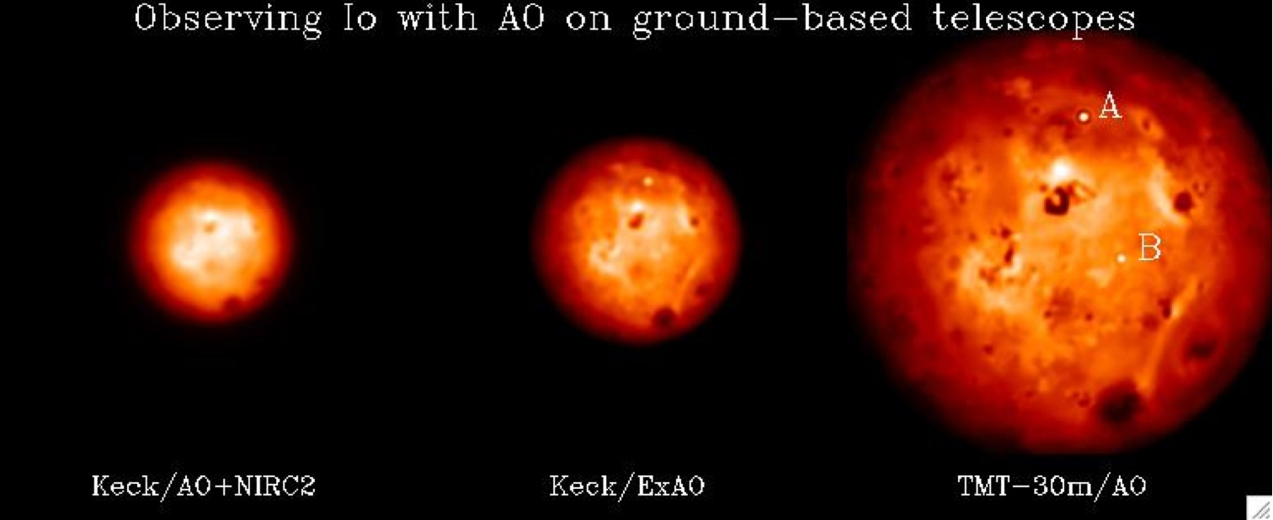
Figure 1: Simulations of Io Jupiter-facing hemisphere in H-band (Courtesy of Franck Marchis, UC Berkeley/SETI). The resolution of TMT at 1 µm is 7 mas (25 km at the distance of Jupiter). The “A” and “B” labels mark active volcanic sites.

Top-level Observatory Requirements

Requirement ID | Description | Requirement
[REQ-1-ORD-3740] | Wavelength range | 0.8 – 2.5 µm
[REQ-1-ORD-3745] | Image Quality | Aberrations uncorrectable by an order 60x60 AO system should not add wavefront errors larger than 30 nm RMS
[REQ-1-ORD-3750] | Field of View, IFU | Up to 3 arcsec for integral field mode
[REQ-1-ORD-3755] | Field of View , imaging | 15x15 arcsec for imaging mode
[REQ-1-ORD-3760] | Detector Sampling | 0.004 arcsec per pixel (Nyquist sampled (λ/2D) over 4096 pixels for IFU)
[REQ-1-ORD-3765] | Detector Sampling | Plate scale adjustable 0.004, 0.010, 0.025, 0.050 arcsec/pixel for IFU
[REQ-1-ORD-3770] | Detector Sampling | Nyquist sampled (λ/2D) (0.004 arcsec) over 10x10 arcsec for imaging
[REQ-1-ORD-3775] | Detector Sampling | Smaller wavelength coverage (Δλ/λ≤ 0.05) is acceptable for area coverage equivalent to 128x128 spatial pixels
[REQ-1-ORD-3780] | Spectral Resolution | R=4000 over J,H,K bands, one band at at a time  R=5-100 for imaging mode
[REQ-1-ORD-3785] | Throughput | > 30%, not including telescope or NFIRAOS
[REQ-1-ORD-3790] | Instrument background | The instrument should not increase the (inter-OH) background by more than 5% (TBC) over the sum of: inter-OH sky, telescope and NFIRAOS background.
[REQ-1-ORD-3795] | Detector | Detector dark current and read noise should not increase the effective background by more than 5% for an integration time of 2000s.

Description

IRIS is a diffraction-limited integral field spectrometer and imager designed to work with NFIRAOS. Its top requirements are given in Table 1, and the layout of the science dewar is shown in Figure 2. IRIS includes a set of deployable wavefront sensors that feed tip-tilt-focus signal back to NFIRAOS. The imager has a field of view of 34”x34” and deliver images with total wavefront errors under 30 nm. The spectrometer will take advantage of two slicing techniques that are suited to different types of science programs. A lenslet channel will maximize image quality whereas a slicer channel will maximize sensitivity. The lenslet will be used to observe at the finest plate scales. It is easy to expand spatially to > 100x100 to sample the entire PSF even at 4 milliarcsec scale. It also has intrinsically low wavefront error because lenslets sample the image plane. A slicer will be used to observe at coarser plate scale. Wavelength coverage can be easily expanded once a sufficiently large field is achieved at coarse scale. Both IFU channels share the same foreoptics as the imager (collimator, filters, rotating pupil mask and crossed Ameci atmospheric dispersion corrector). The selection between the lenslet and slicer paths will be done with simple two-position stages, and the beams will share a common path at the grating. Following the grating, both channels will make use of the same camera and detector.
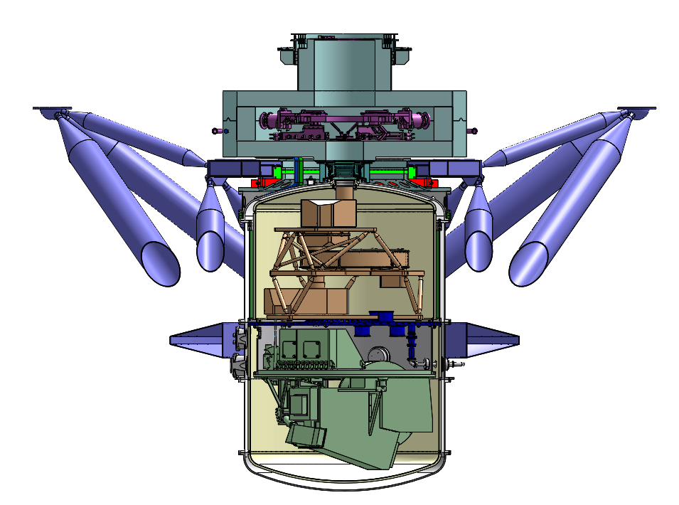
Figure 2: Opto-mechanical layout of the IRIS science dewar. Top portion contains the On Instrument WaveFront Sensors (OIWFS), attachment frame to the NFIRAOS adaptive optics system is shown in purple. The 34”x34” imager is housed in the upper half of the science dewar (tan colored components), the IFU is in the lower half (light green components).

The following organizations are involved in the IRIS science and technical teams: Caltech, UC (Los Angeles, Irvine, Santa Cruz, Berkeley), Herzberg Institute of Astrophysics, and the National Astronomical Observatory of Japan. The PIs is James Larkin (UCLA) and project scientist is Shelley Wright (UC San Diego). Feasibility and conceptual design studies have been completed and externally reviewed. The preliminary design study is currently underway and at an advanced stage, due to be completed in late 2017.

References

- IRIS website: http://irlab.astro.ucla.edu/iris/index.html

Present design has a 34”x34” field of view that will more effectively support high precision astrometric measurements (relative errors ~55 micro-arc sec)

